PE Funding

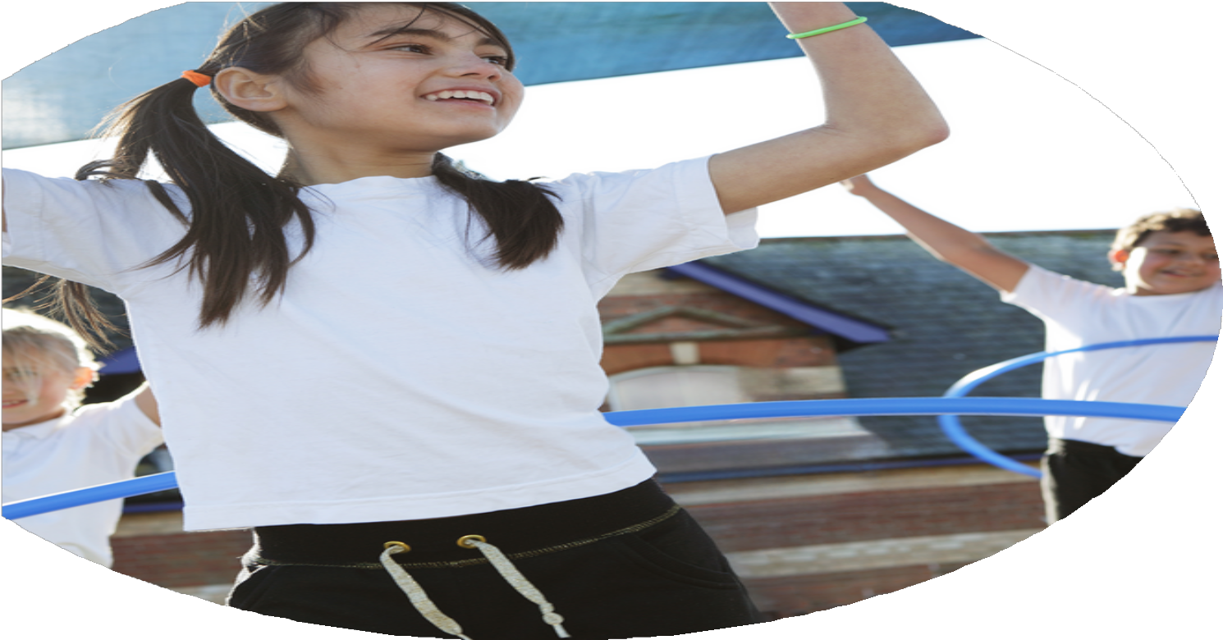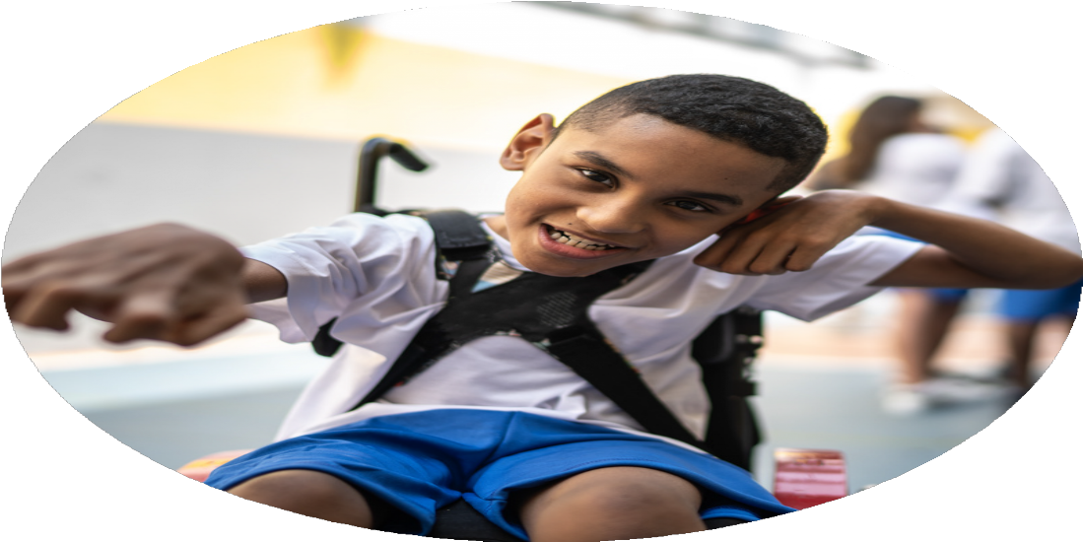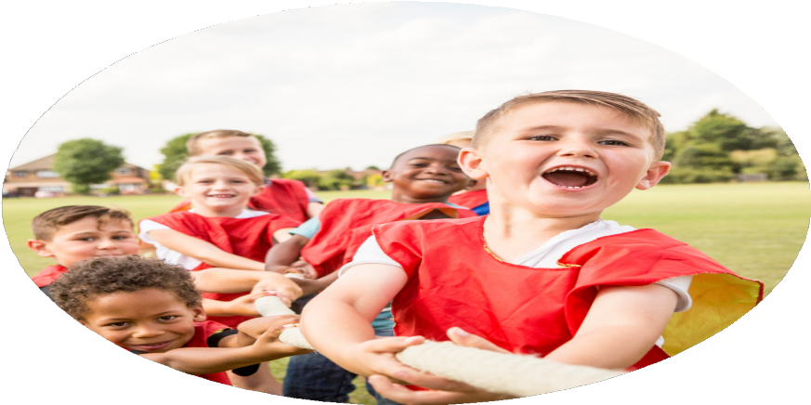

Evaluation Form

**Commissioned by**

**Created by**

Images courtesy of Youth Sport Trust

**PE Funding Evaluation Form**

 It is intended that this template should be used as preparation for the completion of the statutory digital reporting tool being introduced this academic year. You can upload data (including swimming) from this template onto this platform once it becomes accessible.

 Before you decide how you are going to use the funding for this academic year you should reflect and evaluate the impact of your use of the funding in 2024/25.

 All spending of the funding must conform with the terms outlined in the Conditions of Grant document.  The template is a working document that you can amend/update during the year.

 Based on your evaluation of last year’s funding you should decide what you intend to do this academic year, how you will do it, and what impact you expect it to have.

It is important that the funding is used effectively and based on your school’s needs.

 You must use the funding to make additional and sustainable improvements to the PE and sport in your school.  You must develop and add to the PESSPA activities that your school already offers.

*Summative digital reporting from June 2025 will continue to include swimming and water safety information therefore funding can be used to provide top-up lessons where necessary to ensure pupils meet national curriculum swimming requirements.*

All children have been more enthusiastic and active at play times. We have had less behavioural incidents and wellbeing across the school has been high. Children are happier.

Their Physical literacy skills such as balance, coordination and stamina have been enhanced and developed.

Our SEND pupils have gained a lot from OPAL and are experiencing less anxiety as a result.

MOKI has had a huge impact on pupils’ motivation to do the daily mile this term. It has motivated pupils to re-engage and work on their overall stamina/ improve their fitness levels.

It has been difficult for staff to teach the full Gymnastics curriculum, as the main school hall is now also being used as a dining hall as well. There are hot trolleys in the hall and this has meant there is less space to teach gymnastics/ apparatus safely.

**Curriculum**: Space to teach Gymnastics across the school

**OPAL:** Improve physical activity during OPAL play times.

**MOKI:** Innovate our Daily Mile sessions and keep our pupils active throughout the school day

How are you going to action and achieve these plans?

Implementation

5/2

What are your plans for 2025/26?

Intent

Using new Yoga Bugs scheme of work- All pupils learn new ways to be calm and mindful. These skills will support our whole school approach to improve pupil’s self-regulation of emotions. All staff will be more confident in delivering physical activity that impacts pupils' wellbeing and it can be used as an effective teaching tool to support SATS stress, etc.

Using WILD Passports to assess children’s forest school skills, knowledge and competency during forest schools/outdoor learning, will ensure all pupils benefit from developing these key skills.

Ensuring that new teachers and TAs are trained as forest school leaders means that we will have more experienced and knowledgeable staff across the school. This enables all pupils get to access forest schools.

Ensuring high quality P.E lesson sare delivered across the school and staff have the ability to do so, after ‘upskilling’ with new coach.

Ensuring EYFS & Y1 pupils are exposed to high qualify balance bike opportunities where they can work on their Physical Development.

**Yoga bugs:** Improve meditation and spiritual development of our pupils.

Pupils can develop a mindful state and be able to self-regulate their emotions. They can learn how to be calm and find mindful moments. They can then assess and articulate how they feel on a personal level with regards to wellbeing.

**Forest School:** Enhance physical development/skills across the school.

Pupil will learn key skills during forest school sessions and be able to record these achievements in their very own WLD Passports.

**Forest School:** Develop more Staff to be confident delivering Forest School: Train more level 2/3 Forest School leaders so that all pupils benefit from Forest School.

**Coaches/Resources**: Develop physical literacy across the school and improve staff development of skills.

**Balancability Opportunities:** Develop our youngest pupils physical literacy skills (ABC: Agility, Balance & Coordination).

What impact/intended impact/sustainability are you

expecting?

How will you know? What **evidence** do you have or

expect to have?

What **impact/sustainability** have you seen?

What **evidence** do you have?