Meet your Collective Worship Team!
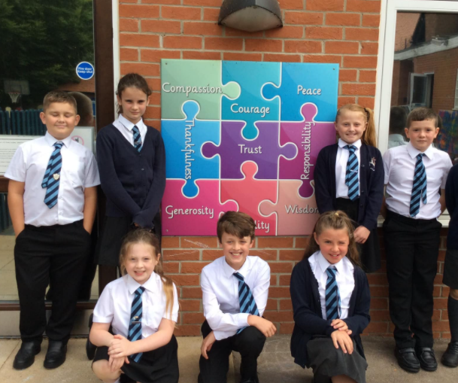
Hello! We are Eve, Alfred, Brooklyn, Ronnie, Miley, Max and Darcie and we are the Collective Worship Council! We are here to help. Is there someone who you think has demonstrated one of our Christian values? Well come to talk to us and we will be happy to celebrate this with the whole school community.

