Religious Education-

What makes every single person unique and precious?

How can we care for our wonderful world?
Physical Development-

Sports Day
How we can stay healthy
Ball Skills
Games
Personal Social Emotional Development-

Relationships
Changing Me

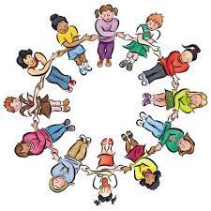

Expressive Art and Design-

Making a giant hot air balloon

Creating a carnival
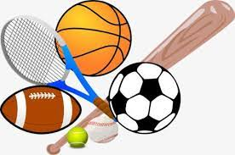
Communication and Language-

Listen to and discuss stories, talk about our and others writing, practicing giving praise
Reception
I wish I were a pilot- Stella Blackstone
Handa’s Surprise- Eileen Browne
Jonah and the big fish

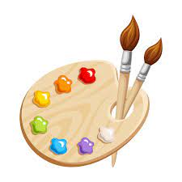
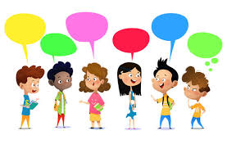

Literacy-
Talk4Writing. Writing about our world, writing about characters in stories, writing a day in the life, describing famous landmarks
Maths-

Subitising, counting, ordering, doubles, patterns
Understanding the World-

Learning about the job of a pilot, Learning about how people live in other countries, focusing on Malawi

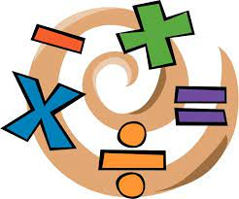
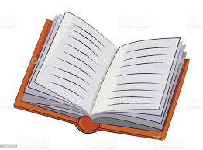

‘All around the world’ – Summer 2023



