Elveden C of E Primary Academy Long-Term Plan
Badgers Cycle A (Year 3/4)
 | Autumn 1st | Autumn 2nd | Spring 1st and 2nd |  | Summer 1st and 2nd
 | Ancient Egypt | Foraging and Hunting | Suffolk Safari |  | Terror on board the Titanic
English Reading | . We will be reading Marcia and the riddle of the Sphinx and Egyptology.  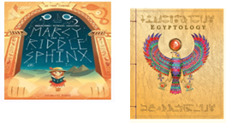 | We will be readying a range of texts such as Stone  Age Boy by Statoshi Kitamura and Stig of the Dump by Clive King and.  Secrets of the Stonehenge by Mick Manning.  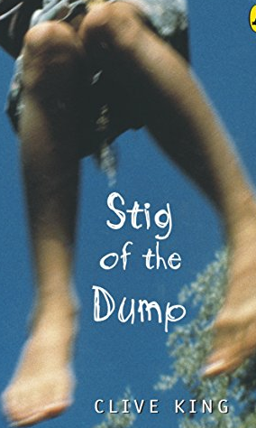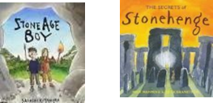 | We will be reading various versions of Oliver Twist and I was a Rat by Phillip Pullman, we will also be reading The Lost Words by Robert MacFarlane.  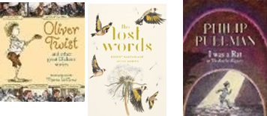  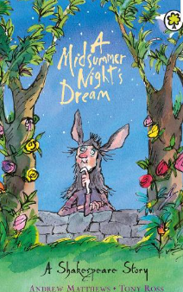 |  | We will be reading Kaspar Prince of Cats by Michael Morpurgo and The Titanic Detective Agency by Lindsay  Littleson.  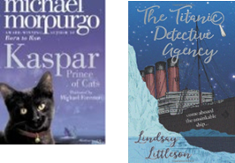
English Writing | We will be writing poetry with the theme Emotions (1 week), first person narratives (2 weeks), Non- Chronological Reports (3 weeks), Formal Letters to complain (2 weeks) ,Dialogue in narrative (3 weeks(, Performance poetry from other cultures (1 week). |  | We will be writing third person narratives (3 weeks), Non chronological reports (3 weeks), advanced instructional writing (2 weeks), first person narrative descriptions (2 weeks) and playscripts (1 week) |  | We will be writing third person narratives (3 weeks), advanced instructional writing (2 weeks), letters to formally complain (2 weeks) , dialogue through narrative (3 weeks)
Maths  (White Rose) | Maths- White Rose Scheme of work –Daily Lesson
Science  (PLAN) | Sound Y4  We will be learning about sound: identifying how sounds are made, the way vibrations travel and finding patterns in pitch and volume. | Rocks Y3  We will be learning about rocks, fossils and soils. | Light Y3  We will also be learning about light: recognising that you need light to see, noticing that light is reflected from surfaces etc.  Plants Y3  We will be looking at plants, learning to identify and describe the key functions of parts of plants, the requirements of a plant for life and growth. We will also be looking at pollination, seed formation and seed dispersal. |  | States of Matter Y4  We will be learning about describing the water cycle and the part played by evaporation and condensation. We will also compare and group materials according to whether they are solids, liquids or gases.  Electricity Y4  We will also be studying electricity: identifying common appliances that run on electricity and conducting simple circuits.
Art and Design |  | Painting  We will be exploring cave painting, recreating cave art using mixed mediums and making our own paint using natural resources.  . | Printing & Sculpture  We will study Andy Goldsworthy and Mike Godwin. We will develop our skills in mono printing and wire sculpture-lost word birds. |  | Drawing  We will be learning sketching skills, such as contrast and tone to create our own picture of the Titanic.
Teach Computing | Project Evolve (Year 3) | Branching Databases (Yr 3) | Data Logging (Yr 4)  Sequencing Sounds (Yr 3) |  | Repetition in Games (Yr 4)  Stop-frame animation (Yr 3)
Design and Technology  (Kapow) | Textiles: Egyptian Collars  We will be using cross stitch and applique skills to create Egyptian collars. |  | Food: Eating Seasonally  Using local produce, we will prepare fruit skewers, make fruit crumbles and cook tarts. |  | Electrical systems: Torches  We will be designing and constructing torches using electrical circuits.
Geography  (Potential geography fieldwork trip to look at habitats) | Human & Physical features  We will be looking at human geography settlements and the geography of Africa (River Nile, land use). Link to climate zones | Map work/ Human & Physical  Using maps and atlases to locate Skara Brae. We will look at the human and physical characteristics of the Orkney Islands and think about why this may have been chosen as a Stone Age settlement. We will also be looking at how some aspects of Geography have changed over time. | Fieldwork  We will be using fieldwork to observe, measure, record and present the human and physical features in Suffolk. We will be looking at this in relation to the different habitats of animals and how this varies across the different regions of the UK. We will be using maps, atlases and digital computer mapping to look at the different countries and cities of the UK. |  | Physical and Locational knowledge  Coasts & rivers, identifying physical characteristics, recognise why the water cycle is crucial for sustaining life, using ordnance surveys to explore different local rivers.
History | The achievements of the  earliest civilizations –  Ancient Egypt  We will be learning about  Ancient Egypt Civilisation. | Changes in Britain from the Stone Age to the Iron Age  We will be finding out about the Stone, Bronze and Iron Age and doing a comparative study between Norfolk and Japan (Ancient House Museum). | A local history study  We will be conducting a local history study focusing on Duleep Singh and his importance to our locality.  We will be finding out about Victorian School life and comparisons of school life between then and now. |  | A study of British history beyond 1066  We will be learning about the chronological significance of the sinking of the Titanic including a study on a Suffolk Survivor: Violet Jessop.
French  (Language Angels) | Phonics Lesson 1 & 2  I’m learning Fr/Sp/lt | Animals | I can  Fruits |  | Presenting Myself  At The Café  (French café)
Music  (Charanga Y3) | Developing Notation Skills  How does Music bring us closer together? | Enjoying Improvisation  What stories does Music tell us about the past? | Composing Using Your Imagination  How does Music make the world a better place?  Sharing Musical Experiences  How does music help us to get to know our community? |  | Learning more about Musical styles  How does Music make a difference to us every day?  Recognising Different Sounds  How does Music connect us with our planet?
PE  (Complete P.E.)  Cycle A | Invasion:  football  Gymnastics:  Symmetry & Asymmetry | Invasion:  Hockey  Dance:  Wild Animals | Invasion:  Tag rugby  OAA  Problem Solving  Swimming |  | Net/Wall:  Tennis  Dance:  Weather/Summer show  Striking & Fielding:  Cricket  Athletics
PSHE  (Jigsaw Y3) | Being Me in My World | Celebrating Difference | Dreams and Goals  Healthy Me |  | Relationships (RSE)  Changing Me (Y3 and 4)
RE  (Emmanuel Units Y3) | Christianity  How do Christians  show that  reconciliation with  God and others is  important? | Islam  How does a  Muslim show their  submission and  obedience to  Allah? | Hinduism  Why do Hindus  want to collect  good karma?  Christianity  Is the cross a symbol  of love, sacrifice or  commitment for  Christians? |  | Christianity  What do Christians  mean when they talk  about the Kingdom of  God?  Judaism  What symbols and  stories help Jewish  people remember  their covenant with  God?
Trips
SMSC | Social Day |  | Moral Day | Spiritual Day | Cultural Day

Trips (possible)
Autumn: Fitz William - Ancient Egypt exhibition
Spring: Ancient House - Duleep Singh (27th January)
Summer: Flatford Mill (waiting to hear dates)

