Key Stage 1— Summer 1st– Amazing Africa

|  |  |  |  |  |  |  |
| --- | --- | --- | --- | --- | --- | --- |
| Week 1:  Letters | Week 2:  Letters | Week 3:  Character Description | Week 4:  Pattern and Rhyme  African Poetry | Week 5:  Story Writing | Week 6:  Story Writing | Week 7:  RE Literacy Week |

R.E:

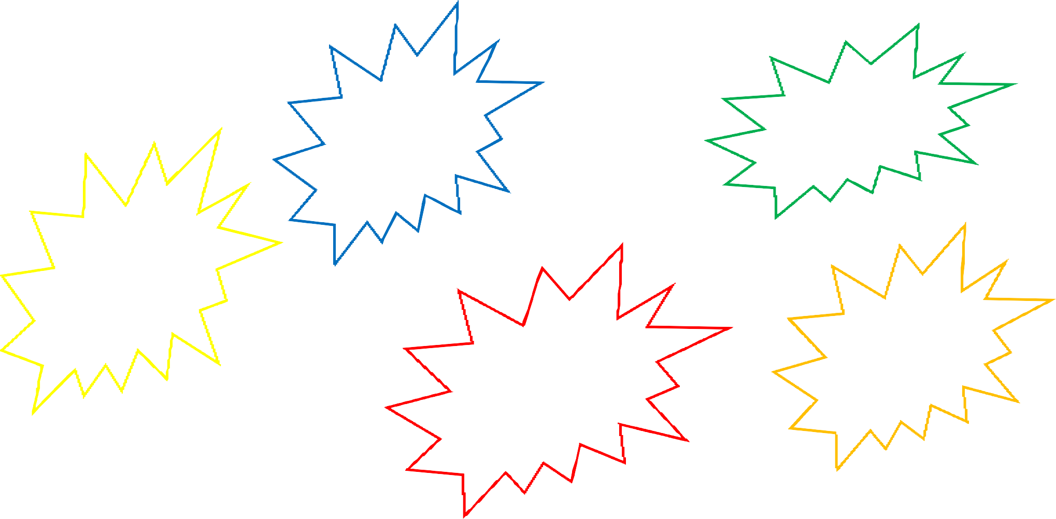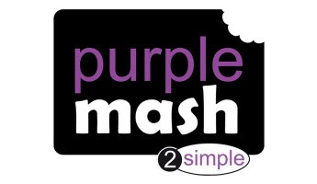

We will be learning about faith and disciples through Christianity.

RSHE:

Relationships (Jigsaw)

Music

We will be studying South Afri- can music and freedom songs.

(Friendship song-Year 2)

P.E:

Games (Net and Wall) OAA

Computing: Spreadsheets (Unit 2.3) Pictograms ( Unit 1.3)

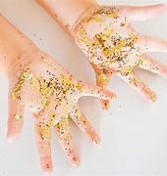

Session 1

L.O: I am learning to describe the im- portance for humans of hygiene.

We will use an aerosol spray to show the effect of a sneeze. We will be exploring using the can to spray onto large pieces of paper at different distances to see the effect of a sneeze.



Session 2

L.O: I am learning to describe the im- portance for humans of hygiene.

We will be devising a test to find out how germs transfer from primary sources to secondary and the im- portance of washing our hands thor- oughly.

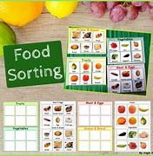

Session 3

L.O: I am learning to describe the im- portance to humans of eating the right amounts of different types of food.

We will be looking at pictures of food and asked to sort them in as many different ways as we can. We will then label the groups using post it notes.

They then used a Carroll diagram to record some of our

classifying.

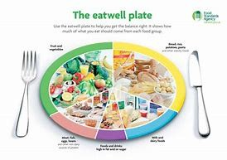

Session 4

L.O: I am learning to describe the im- portance for humans of eating the right amounts of different types of food.

We will record the food that they chose for lunch onto the eatwell plate. We will then suggest improvements which could be made

to our lunch.

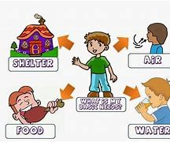

Session 5

L.O: I am learning to find out about and describe the basic needs of hu- mans for survival.

We will be given cards in small groups to sort according to whether a baby would need or

not need these things. We will then write our ideas down about what we



Session 6

L.O: I am learning to describe the importance to humans of exercise.

We will do a range of different exercises and make a series of observations of the changes to our bodies during

different exercises.

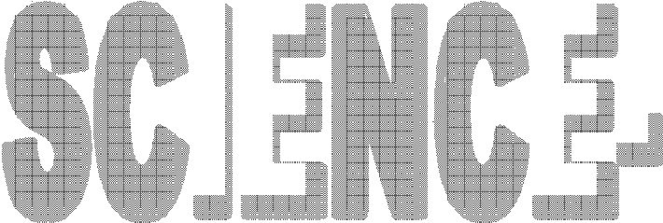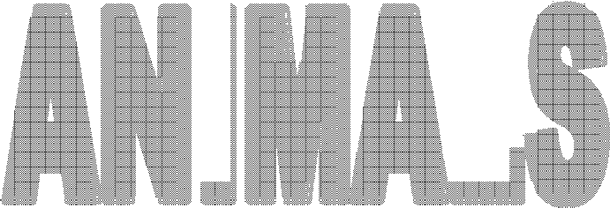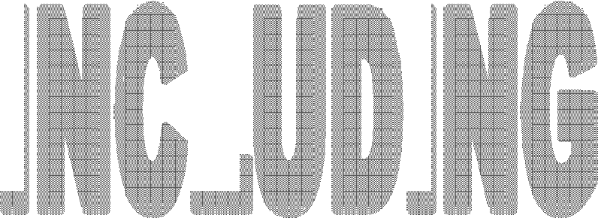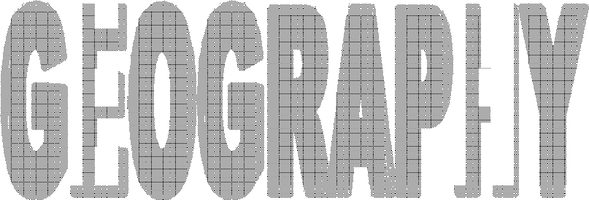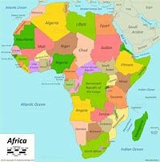

Session 1

L.O: I am learning to identify where Africa is on the map.

We will be locating Africa on the world map and locating the UK. We will look at the countries which make up Africa. We will be mind mapping ideas of what we think it would be like to live in Malawi.

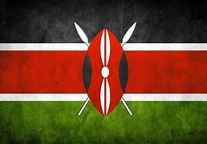

Session 2

L.O: I am learning what it is like to live in Malawi.

We will be learning all about Malawi. We will be looking at what it is like to live in Malawi.

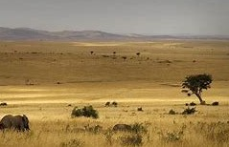

Session 3

L.O: I am learning to compare the cli- mate in Malawi to the UK.

We will be looking at what the weather is like in Malawi compared to the UK. We will be making a weather forecast for both Malawi compared to the UK.

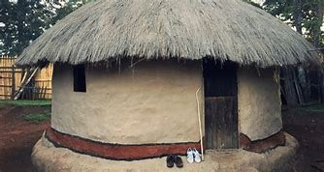

Session 4

L.O: I am learning to compare villages in the UK to Malawi.

The children will be comparing pictures of the homes in the UK and in Malawi and discussing them. We will then write the key information we have learnt looking at the similarities and differ− ences.

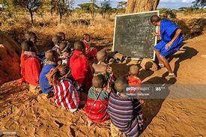

Session 5

L.O: I am learning to understand what it is like for a child living in Malawi.

What is daily life like in Malawi? We will be following through a typical school day for a child living in Malawi and thinking about how this compares to our school day.

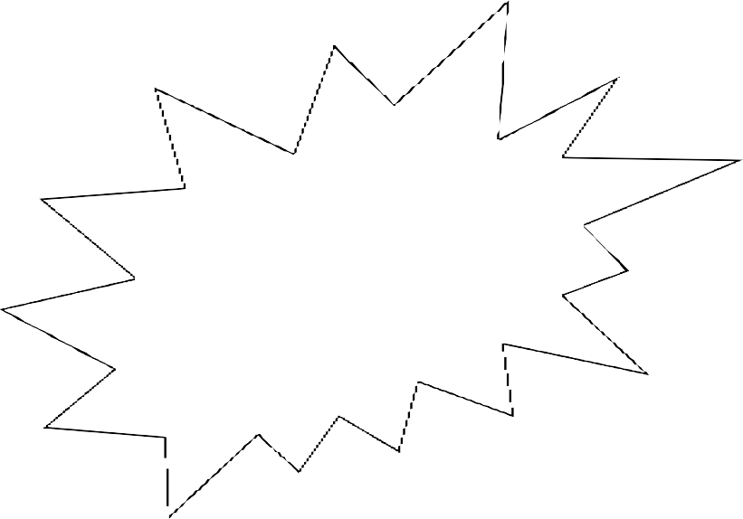

We will be looking at pictures and connecting with our part− ner school in Malawi.

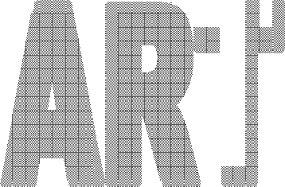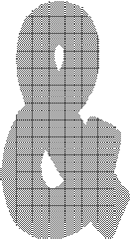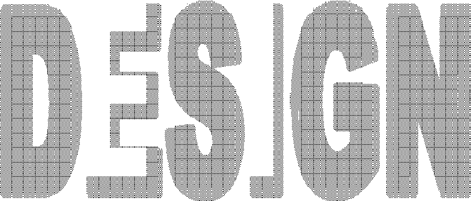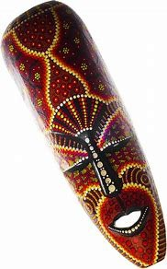

Session 1:

L.O: I am learning to explore materials.

We will looking at African masks and the patterns, colours and designs on them.



Session 2:

L.O: I am learning to design a product.

We will be designing our own African masks. We will be thinking carefully about what patterns and designs we would like on them and start by planning our own mask.

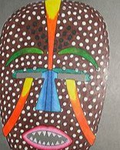

Session 3

L.O: I am learning to use a range of materials to make a product.

We will be making our own African masks using clay or paper mache. We will use the plans we created in the previous lesson to

help us.



Session 4:

L.O: I am learning to add colour,

pattern and texture to an object.

We will be finishing our own African masks adding details to our masks thinking carefully

about the colours

and patterns.

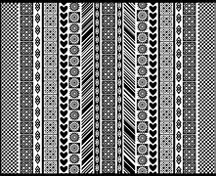

Session 5:

L.O: I am learning to explore a range of materials.

We will be exploring Adrinkra fabric

printing and looking at examples.

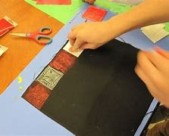

Session 6:

L.O: I am learning to use basic objects, tools

and equipment to make patterns and images.

We will creating our own Adrinkra fabric printing.