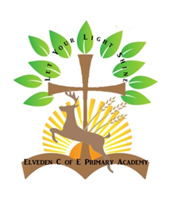**Religious Education**

As a Church School we seek to promote the religious, spiritual, moral, social and cultural development of our children through R.E. We enable children to reflect upon and respond to religious and spiritual beliefs, practices, insights and experiences. The experiences offered to our children are based on the beliefs and traditions of Christianity. We follow the Suffolk Agreed Syllabus of ‘The Emmanuel Units’. We explore other religions such as Islam, Judaism and Hinduism in order to deepen understanding in a multi-cultural and multi-faith world and we promote Christian values in everything we do.

Our Local Committee members (LAC) and the Diocese work collaboratively to monitor and support our Religious Education and ensure that we provide quality experiences for the children so they can develop as citizens of the world. We receive regular updates from Rachel Cutts who is the Schools’ Advisor for Religious Education.

All children take part in an act of Collective Worship every day and have opportunities for quiet reflection in their own classroom reflection areas (our Spiritual Classroom and Well-being Garden). We have prayers at the end of each day and before meals. All children are invited to take part and show respect for each other. These are opportunities for them to take time to reflect on a Christian value or have a quiet moment in a busy day to develop their spiritual awareness. We also have ‘5 minutes peace’ at the end of every lunchtime to help regulate and return to a sense of calm before our afternoon teaching begins. We are supported through our link with the local parish and we are able to use both the school and the nearby church (St Andrew and St Patrick’s) for our Religious Education.