Elveden C of E Primary Academy Long-Term Plan
Year 2 Transition Year - Cycle A 2025/26
 | Autumn 1st |  | Autumn 2nd | Spring 1st | Spring 2nd |  |  |  | Summer 1st | Summer 2nd
Topics | Once Upon a Playground! |  |  | From Acorns to the Amazon! |  |  |  |  | Wheels, Wings and Waves!
 | Exploring how children’s lives have changed within and beyond living memory through the changes to schooling and toys since the Victorian era. |  |  | Exploring the history of Thetford Forest and comparison with the Amazon Rainforest. |  |  |  |  | Exploring the lives and achievements of Charles Burrell, The Wright Brothers (change to Amelia Earhart for 2025/2026) and Captain Cook.
Enrichment |  |  | Guy Fawkes 1 week for Bonfire night.  Nativity  Christmas | Easter |  |  |  |  |  | Sports day
Trips | Ancient House Toy Workshop(History) |  |  | Zoo (Science link) |  |  |  |  | Charles Burrell Museum (History)
Curious Quests  English - Writing  (Text types) | Fiction  Character descriptions  (2 weeks)  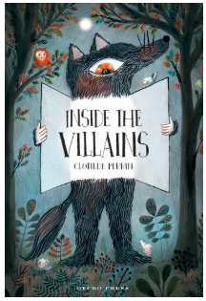  Non-Fiction  Letters  (2 weeks)  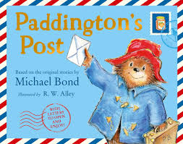  Poetry  Developing vocabulary  (1 week)  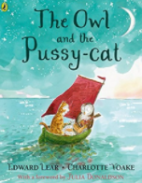 |  | Fiction  Stories with familiar settings  (2 weeks)  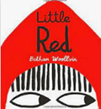  Non-Fiction  Recounts from personal experience  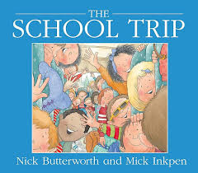  Poetry  On a theme – humorous  (1 week)  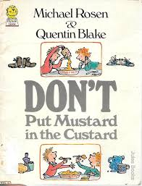 | Fiction  Setting descriptions  (2 weeks)  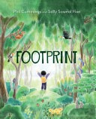  Non-fiction  Instructions  (2 weeks)  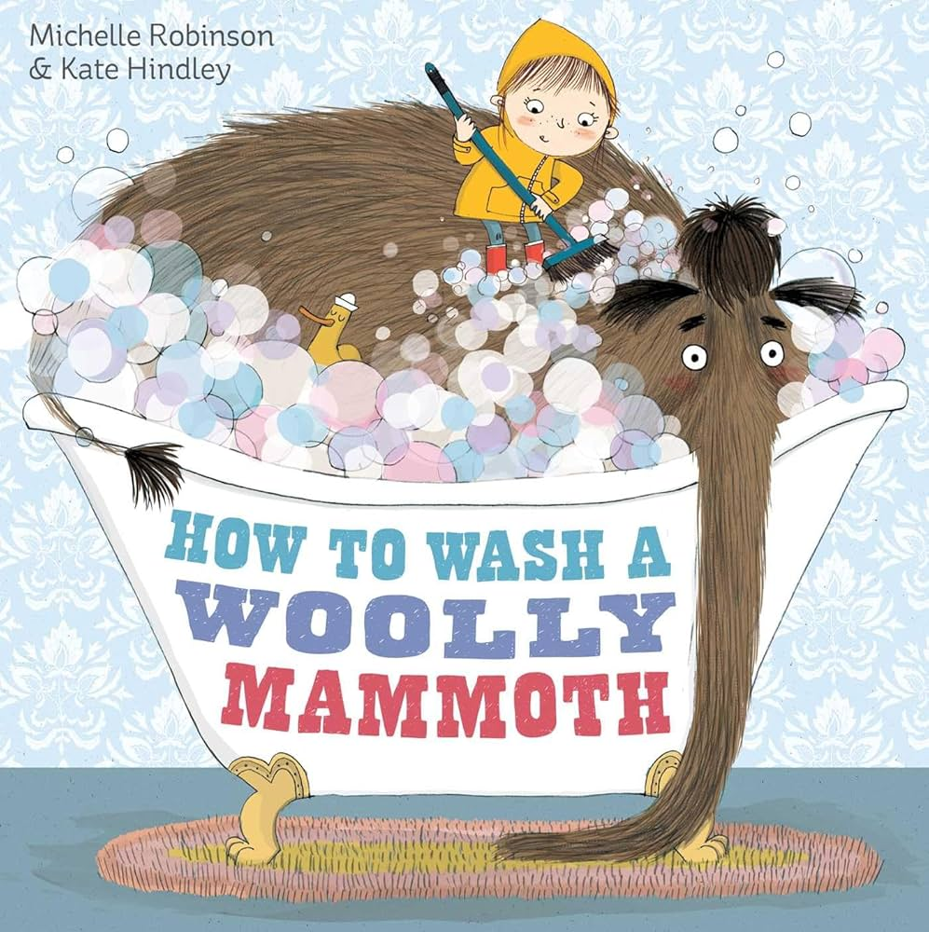  Poetry  Playing with language  (1 week)  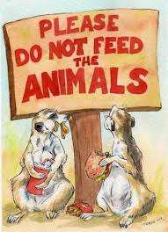 | Fiction  Stories from other cultures  (2 weeks)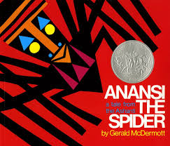  Non-fiction  Non-chronological reports  (2 weeks)  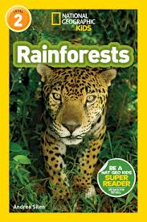  Poetry  On a theme - nature  (1 week)  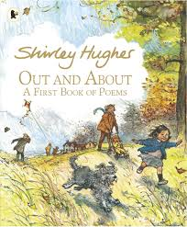 |  |  |  | Fiction  Stories with familiar settings  (2 weeks)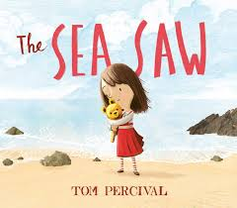  Non-fiction  Persuasive leaflet  (2 weeks)  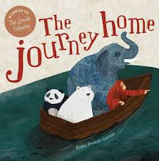  Poetry  Pattern and rhyme  (1 week)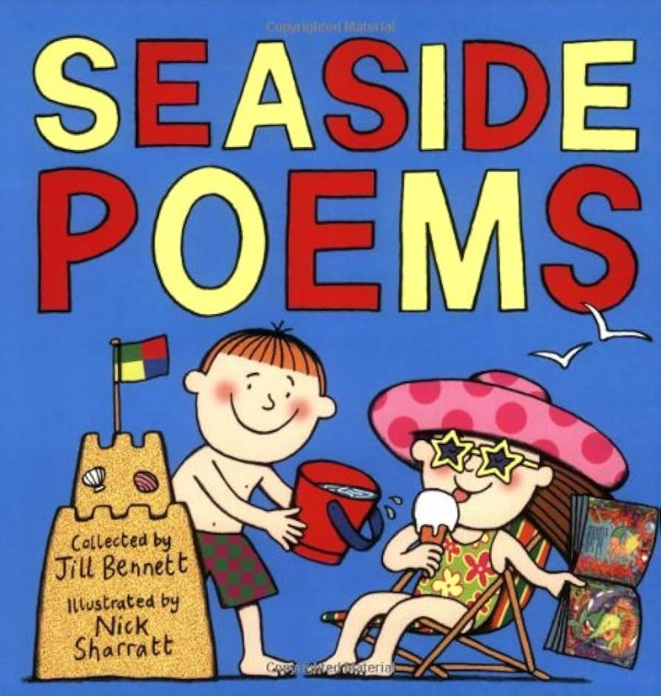 | Fiction  Retelling of a narrative  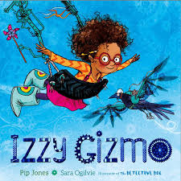  Non-fiction  Recounts from personal experience  (2 weeks)  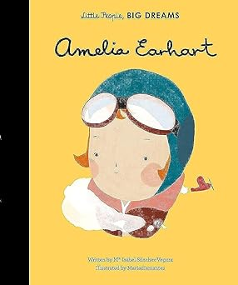  Poetry  On a theme - vehicles  (1 week)  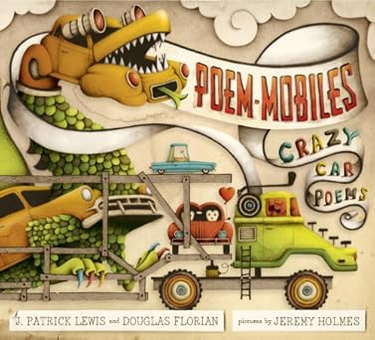
Reading Vipers  Fiction  (3 weeks)  Non-fiction  (2/3 weeks) | 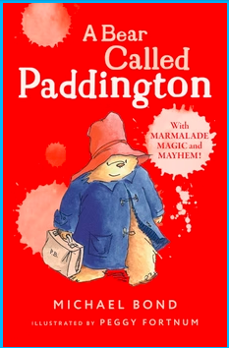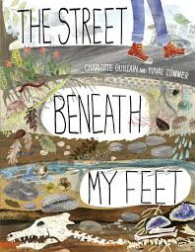 |  | 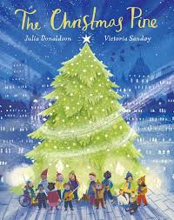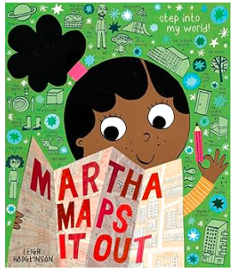 | 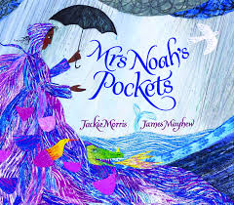  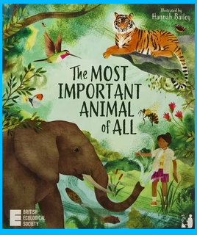 | 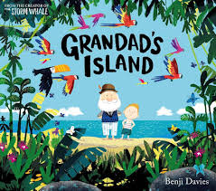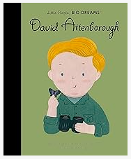 |  |  |  | 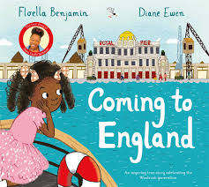  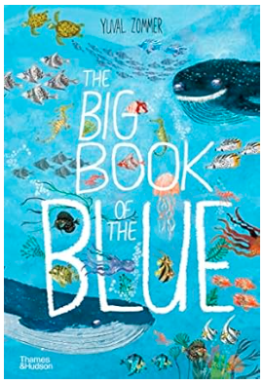 | 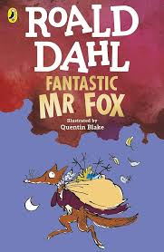  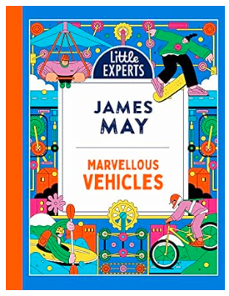
Maths  (White Rose) | Maths- White Rose Scheme of work –Daily Lesson  and  Mastering Number Programme NCETM x4
 | 3 ½ Weeks: Place Value (within 20) 16 lessons & end of unit assessment.  3 Weeks: Addition and Subtraction (within 20) |  | 4 Weeks: Place Value (within 100) 21 & end of unit.  3 Weeks: Shape  12 lessons. | 2 ½ Weeks: Money  10 lessons & end of unit.  3 ½ weeks - Multiplication and Division. | 1 Week: Multiplication and Division  2 Weeks: Length and Height  2 Weeks: Mass, capacity and temperature |  | 3 Weeks: Fractions  2 weeks: Time |  |  |  | 2 Weeks: Statistics  1 week: Geometry position/direction
Foundation subjects
Science  (PLAN) | Uses of Everyday Materials  (Year 2)  We will be identifying and comparing the suitability of a variety of materials for particular uses including wood, metal, plastic, glass, brick, rock, paper and cardboard for particular uses.  We will find out how the shapes of solid objects made from some materials can be changed by squashing, bending, twisting and stretching.  Animals, including humans  Find out about and describe the basic needs of animals, including humans, for survival (water, food and air).  To describe the importance for humans of exercise, eating the right amounts of different types of food, and hygiene. |  |  | Living things and their Habitats Y2 (Part 1)  We will explore and compare the differences between things that are living, dead, and things that have never been alive. We will begin to identify that most living things live in habitats to which they are suited.  Living things and their Habitats Y2 (Part 2)  We will identify and name plants and animals in their habitats, including micro-habitats  Describe how animals obtain their food from plants and other animals, using the idea of a simple food chain, and identify and name different sources of food. |  |  |  | Plants Y2  Observe and describe how seeds and bulbs grow into mature plants  Find out and describe how plants need water, light and a suitable temperature to grow and stay healthy.  Animals, including humans  Notice that animals, including humans, have offspring which grow into adults.
Art and Design | Materials and Textiles  We will be using objects and basic tools to create patterns and images. |  |  | Drawing  We will be sketching and drawing our own pictures, exploring tone and shade. |  |  |  | Sculpture  We will be working with malleable materials and exploring shape and form. We will be sculpting animals from the land, sea or sky.
Design and Technology  (Y1)  KAPOW |  | Textiles: Puppets  We will be using materials and sewing skills to make our own puppets. |  |  |  | Stable Structures:  We will be learning about freestanding structures and design and making our own pencil pot. |  |  |  |  |  | Mechanisms: wheels and axles  We will be designing and making our own vehicles.

Geography | Geography skills and fieldwork  We will be using fieldwork and observational skills to study the geography of the school and its grounds. We will be identifying the key human and physical features in its surrounding areas.  We will devise a simple map of the school and its grounds, using and constructing basic symbols in a key. |  | Locational Knowledge  We will be naming, locating and identifying characteristics of the four countries of the United Kingdom. We will use basic geographical vocabulary to refer to the human and physical features.  Place Knowledge  We will be comparing the geographical similarities and differences of Elveden and Thetford Forest with Manaus, Brazil in the Amazon Rainforest through studying the human and physical geography.  We will use basic geographical vocabulary to discuss human and physical features.  Geographical skills and fieldwork  We will learn to use maps, atlases and globes to identify the UK and the country of Brazil. We will identify the continents of Europe and South America. We will identify the nearest oceans. |  | Locational Knowledge  We will be learning to name and locate the world’s seven continents and five oceans.  We will be learning to name and locate the seas surrounding the UK.  Geographical Skills and Fieldwork  We will use maps and atlases to identify the countries, continents and oceans linked to the significant explorers.  We will be learning to use simple compass directions and locational/directional language to describe routes on a map linked to the significant explorers.
History | Changes within and beyond living memory  We will be learning about toys and schooling through time and how they have changed since the Victorian era.  Significant individuals  We will be learning about Queen Victoria and comparing the life and rights of children with that of today.  We will learn about Dr. Barnardo and the impact he had on improving the lives of children.  Significant events, people and places in the local area  We will be learning how school has changed throughout time and look particularly at how Elveden Primary has changed. |  | Significant Events in local area  We will be learning about the history and heritage of Thetford Forest since 1922 to the present day. |  | Significant events, people and places in the local area  We will be learning about Charles Burrell and his local work using steam transport.  Events beyond living memory/Significant people  We will be learning about Captain James Cook and his voyages of the Pacific and Southern Oceans.  2025/26 ONLY  We will be learning about Amelia Earhart and how she was a pioneering female pilot.  We will be learning about Christopher Columbus and how he was one of the first Europeans to explore America.  2026/27 ONWARDS  We will be learning about the Wrights Brothers and how they invented the first aeroplane. (current cohort have already done this)
French | We will be reading the French version of Happy Birthday. |  | We will be reading Goldilocks and the Three Bears in French-English. |  | We will be reading the French-English version of Handa’s Surprise.
Computing  (Y1) | Technology around us  (Yr. 1) | Digital Writing  (Yr. 1) | Grouping Data  (Year 1) | Pictograms  (Yr. 2) | Moving a robot  (Yr. 1) | Robot Algorithms  (Yr. 2)
Music  (Charanga Y1 MMC) | Introducing Beat  How can we make friends when we sing together? | Adding Rhythm & Pitch  How does Music tell stories about the past? | Introducing Tempo and Rhythm  How does Music make the world a better place? | Combining Pulse, Rhythm and Pitch  How Does Music Help Us Understand Our Neighbours? | Having Fun With Improvisations  What Songs Can We Sing To Help Us Through The Day? | Explore Sound and Create A Story  How Does Music Teach Us About Looking After The Planet?
PE  (Complete P.E.-Cycle A/Y1) | Locomotion  Running  Dance: Growing | Ball Skills: Hands 1  Dance: Nativity | Ball Skills: Feet  Gymnastics: Wide, Narrow, Curled | Ball Skills: Hands 2  Gymnastics: Body Parts | Locomotion: Jumping  Games For Understanding | Team Building  Health and Wellbeing
PSHE  (Jigsaw Y1) | Being Me in My world | Celebrating Difference | Dreams and Goals | Healthy Me | Relationships | Changing Me (RSE)  Year 2
RE  (Emmanuel Units Y1) | Big Question: Is it important to belong? |  | Big Question: Why do people celebrate? |  | Big Question: Should everyone learn to pray?
 | Christianity  Baptism / church  Why is belonging  to God and the  church family  important to  Christians? | Judaism  Mitzvat /  tzedakah  Why is learning to  do good deeds so  important to  Jewish people? | Christianity  Resurrection/  What are the best symbols of Jesus’ death and resurrection at Easter? | Hinduism  Devotion/  How does a Hindu celebrate devotion to a deity at the festival of Holi? | Judaism  Tefillah/ blessings  Why do Jewish  families say so many  prayers and  blessings? | Christianity  Worship/  Why do Christians pray to God and worship him?
SMSC | Social Day |  | Moral Day | Spiritual Day |  | Cultural Day

