Elveden C of E Primary Academy

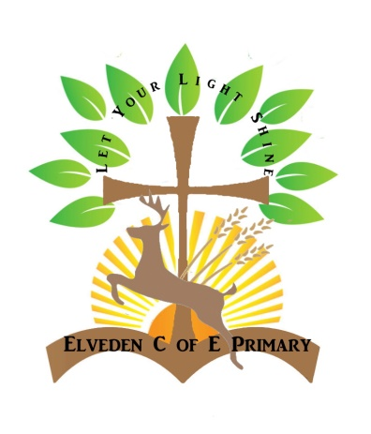

Early Years Foundation Stage Policy

Date Completed: November 2024

Completed by: Danielle Sanders & Molly Westbrook

Review Date: November 2025

Elveden C of E Primary Academy
Foundation Stage Policy

Elveden C of E Primary Academy has an established Foundation Stage, consisting of a Reception class in a stand-alone building with its own adjoining outdoor area. In the foundation stage, we provide all children with the opportunity to develop to their full potential in a setting where they feel safe, valued and happy, and where learning is enjoyable. Each child will experience the best possible start to their education with secure foundations on which future learning can be built.
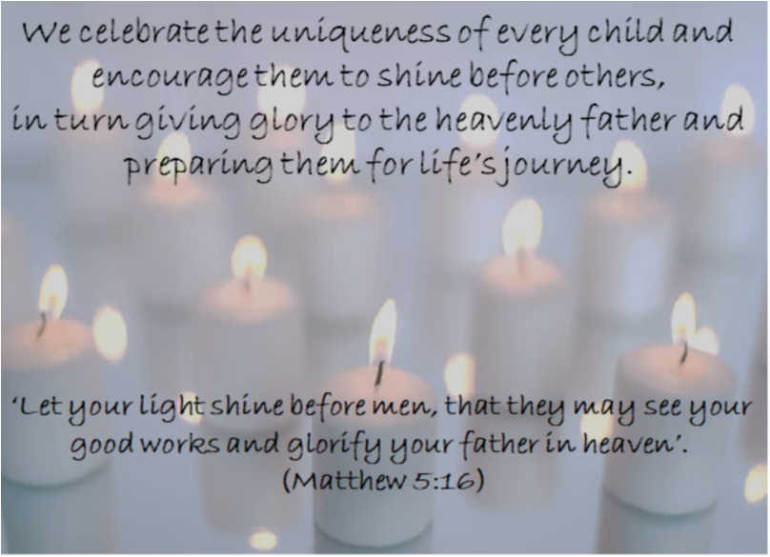

Our Vision
We celebrate the uniqueness of every child and encourage them to shine before others, in turn giving glory to the heavenly father and preparing them for life’s journey.
“Let your light shine before men, that they may see your good works and glorify your father in heaven.” (Matthew 5:16)

Mission and Ethos Statement
At Elveden C of E Primary Academy, we aim to serve our community by providing an education of the highest quality within a framework of Christian belief and values. We encourage an understanding of the meaning and significance of faith, and promote Christian values through the experiences we offer to all of our children.

EYFS curriculum statement

We have our own curriculum statement that runs alongside the whole school curriculum statement. This outlines our intent, implementation and impact in more detail and can be found on our school website.

The Curriculum
The Reception follow Statutory framework for the early years foundation stage, which is available at
https://assets.publishing.service.gov.uk/media/670fa42a30536cb92748328f/EYFS_statutory_framework_for_group_and_school_-_based_providers.pdf
The EYFS framework includes seven areas of learning and development that must shape educational programmes in early years settings.

The prime areas are:
• Communication and Language – listening, attention, understanding and speaking
• Physical Development – gross motor skills, fine motor skills
• Personal, Social and Emotional Development – self regulation, managing self, building relationships

Providers must also support children in four specific areas, through which the three prime areas are strengthened and applied.

The specific areas are:
• Literacy – comprehension, word reading, writing
• Mathematics – number, numerical patterns
• Understanding the World – past and present. People, culture and communities. The natural world
• Expressive Arts and Design – creating with materials, being expressive and imaginative

Religious Education and Collective Worship
As a Church of England Primary School, Children at Elveden Academy have a discrete R.E. lesson each week as well as learning about the values of Christian worship embedded throughout the curriculum. In reception, children meet ‘Tom and Tessa’ who guide them through a way of life through a Christian perspective. Children have opportunities to relate their lives to that of ‘Tom and Tessa’ in an exploratory way. This encourages children to develop discussion and relate their knowledge and understanding of Christianity to their own lives. Reception children attend collective worship daily and say the school prayer as part of the ethos of the school. Daily reflection time is also embedded, this allows children to think about the Values for Life themes and how they can demonstrate them in practice.

Characteristics of Effective Learning
The EYFS also includes the characteristics of effective teaching and learning. The teachers plan activities with these in mind. They highlight the importance of a child’s attitude to learning and their ability to play, explore and think critically about the world around them.
The three characteristics are;
• Playing and Exploring – children investigate and experience things, and ‘have a go’
• Active Learning – children concentrate and keep on trying if they encounter difficulties, and enjoy achievements
• Creating and Thinking Critically – children have and develop their own ideas; make links between ideas, and develop strategies for doing things.

Planning
We present children with a planned curriculum which fosters learning and is challenging and progressive and will extend what they already know. Each half term we plan a topic which focuses on stories from Pie Corbett reading spine to enhance their understanding. This includes a balance of adult focused and child initiated activities.

Our topics include:

- Getting to know you
- Down on the Farm
- Let’s Celebrate!
- Out of this World
- All things Royal
- Dinosaurs Roar!

Planning starts from what the children can already do and builds on their existing experience and skills through play activities. There is a gradual progression through structured play towards the Early Learning Goals. The activities planned provide opportunities for children to extend their experience and learning in a positive, exciting and challenging environment. Children are encouraged to be independent, at an appropriate level, through readily available and well organised resources and activities. Adult support is planned to make the best possible use of all staff and helpers in the setting.
Children with special educational needs are identified early and appropriate arrangements are made for them, so they can access the curriculum.

Play
Learning through play is an important part of our Early Years. Children learn best from activities and experience that interest and inspire them. We provide children with stimulating, active play experiences in which they can explore and develop their learning to help them make sense of the world. They have opportunities through their play to think creatively and critically alongside other children. They are able to practice skills, build upon and revisit prior learning and experience in their own time and at their own level. Play gives children the opportunity to pursue their own interests and encourage others around them. The children learn to adapt, negotiate, communicate, discuss, investigate and ask questions. We provide opportunities for the children to make choices and become independent in their learning. Our children will be given uninterrupted time to become engrossed in, and complete activities of their choice. It is important that adults take an active role in child initiated play through observing, modelling, facilitating and extending their play.

Outdoor Play
All children will be given the opportunity to play outside throughout most of the day whatever the weather. It is important that parents dress their child for school appropriately: warm clothes and waterproof coat when it is cold and wet; sun hat and sun screen when it is sunny.
Children get wet, muddy and messy when they play outside. We provide protective clothing for them to wear, although parents can provide these things for their own child if they wish. We teach children how to minimize how messy they get and they do get better at this as they get older, but it is part of their learning and development - you cannot expect them not to get messy while playing. Children must be allowed to experience the world around them in a full, messy, muddy, wet environment if they are to make useful meaning of it.
EYFS also have access to Forest School teaching which takes place off site. This is staffed by trained Forest school leaders, teaching assistants and volunteers.

Opal Play (Lunchtime)
The children’s play is freely chosen, self directed and intrinsically motivated.
"Elveden C of E Primary School has just achieved Platinum award status from OPAL Outdoor Play and Learning. This means that they are in the top 0.5% of UK schools for the quality of the play they provide for all their children. The school has demonstrated that it takes the UNCRC Article 31, the child's right to play, seriously and is implementing all stages of school improvement in relation to play, including policy, planning, resourcing, staffing and evaluation." Michael Follett BA Hons Ed, PGCE OPAL Founder and Director

Adult/child Ratio
At Elveden C of E Primary Academy, in the Reception class, we have one teacher and one teaching assistant. We may offer extra TA support for children with SEN and those who need some additional help.

Accommodation/ Setting
The setting is reviewed regularly to ensure that it is safe.
The classroom is equipped so that children have a stimulating and inspiring environment to explore and investigate a large variety of equipment and resources, with opportunities for active and quiet play.
Outdoors there are different surfaces, textures, seating and planters. There is also a large climbing frame with safety surface, sand pit, water area, mud kitchen, reading and performing stage, writing, math and role play areas. Children have a variety of planned activities to investigate outside every day, whatever the weather. These activities cover all 7 areas of learning.

Equal Opportunities
Every child has a right to feel valued and secure regardless of social, cultural, religious, emotional and intellectual differences. Religious and cultural diversity are celebrated by providing displays, covering a range of topics and using appropriate resources and artefacts. Where possible, other adults and family members who represent other cultures are welcomed into the setting. This helps to broaden the children’s experience they can providing us with information, photos, food and talk about festivals and traditions. No child is excluded on the grounds of culture, religion, educational needs, disability or gender.

Ensuring children feel valued, secure and confident
The school recognises the need for physical and emotional security as well as confident children. A happy, confident child is receptive to learning, because a child who achieves and succeeds develops confidence and self-esteem. We always ensure that children are presented with achievable but challenging activities. The child’s self-esteem and belief in his/her ability are preserved at all cost by moving forward at a pace that is right for the individual.
We provide an atmosphere where all children and adults value all others. Children are encouraged to be caring, to co-operate, to support and to nurture each other. All problems are taken seriously and children are encouraged to discuss them with a member of staff. We promote an open culture where children know their problems will be addressed. Any issues of bullying are dealt with promptly following the school behaviour and anti-bullying policy.

Parent Partnerships
We recognise the value of parents and carers as their child’s first teacher and provide opportunities to develop strong partnerships with them. We believe that all parents, carers and other family members have an important role to play in the education of their child. We do this through;

- Welcoming parents into school and working with them to establish a positive and supportive partnership between home and school.
- Talking to parents about their child before their child starts school
- The Reception teachers visiting children in their pre-school or home setting prior to starting school.
- Children having the opportunity to spend time in their class before starting school.
- Inviting all parents to an induction meeting before their child starts school.
- Using Tapestry, our online Learning Journey, to keep parents informed of their child’s progress on a regular basis and allowing parents to reply to the observations and send us the achievements their child has made at home.
- Offering play and stay sessions on a variety of subjects.
- Encouraging parents to talk to the child’s teacher if there are any concerns.
- Formal meetings for parents at which the teacher and the parents discuss the child’s progress in private.
- Keeping parents informed of planned topics and activities through regular facebook updates, Tapestry and on the website.
- Running parent workshops to share ideas they can work on with their children at home.
- Sending a report on their child’s attainment and progress mid-year and towards the end of the child’s time in Reception.

Assessing and observations
Assessment is an essential part of the learning and development of children in the Early years. Children are observed by staff to accessing their level of development, their interests and learning styles. We observe them through child initiated activities and some adult focused activities, collecting samples of work, photos and listening to what they tell us. The observations inform future planning, provide information to target their learning priorities and to plan relevant activities and experiences. The information is collated in each child’s workbooks, on Tapestry and Arbor and will also include information and observations provided by parents.

Safeguarding
The school takes its child protection responsibilities very seriously. Any concerns, which the school has, will be noted and, if deemed necessary, will be reported to the relevant agency. The safety of the child is always of paramount importance. The full Safeguarding Policy is available in school and online for parents to read if they wish.

Positive Behaviour Management
The Reception class follows the same Positive Behaviour Management policy and systems as the rest of the school. Please refer to Behaviour Management Policy and Principles for more information.

Monitoring and Review
It is the responsibility of the EYFS staff to follow this policy. The Senior Leadership Team will carry out monitoring on the EYFS as part of the whole school monitoring system.

