# Summer 2nd 2024



Dear Parents,

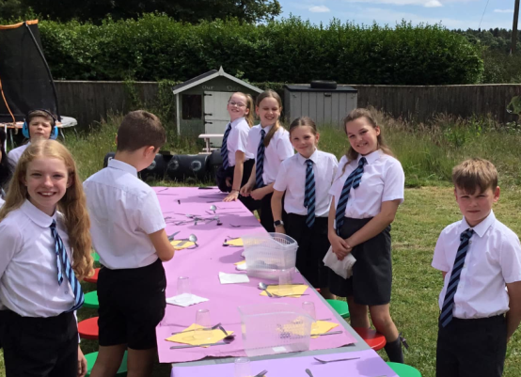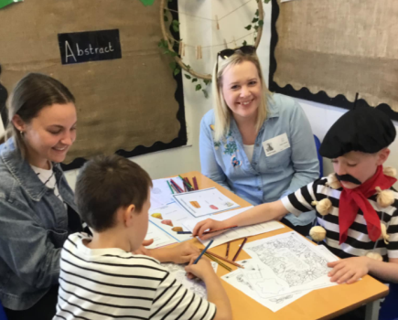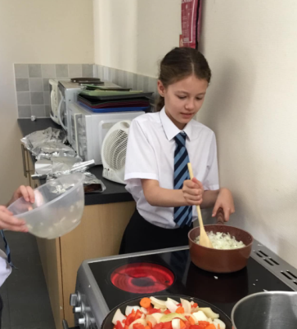

What a fantastic month we’ve had Elveden C of E Primary Academy. A few absolute highlights for us have been the French Cafe, the trip to Roar for Squirrel Class, Primary School Games for Badgers and of course Come Dine with Me by Red Deer.

Thank you to everyone who came to the French Cafe—it was fantastic to see so many connecting with your children and turning up to support the school.

We continue to talk to the children everyday about letting their light’s shine and encouraging attendance and we hugely appreciate your support with that.

The Elveden Academy Team

We’ve enjoyed taking the children on a number of trips and events in the last few weeks: from Come Dine with me to French Café, we have been making memories!

.

Attendance

Attendance Reminder

Attendance is so important to each child’s progress and routine of being in school.

Please send your child into school whenever possible and we will be in contact if we think they’re not well enough to remain in school.

Attendance Target for Elveden: 97%

Current Attendance at Elveden Academy: 95.5% (Whole School)

Year Group Attendance

Reception: 94.82% Foxes: 95.57%

Badgers: 95.84 % Red Deer: 95.5%

It’s vital that the children are at school at every opportunity—thankyou for your support with this.



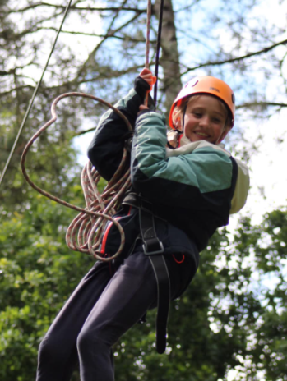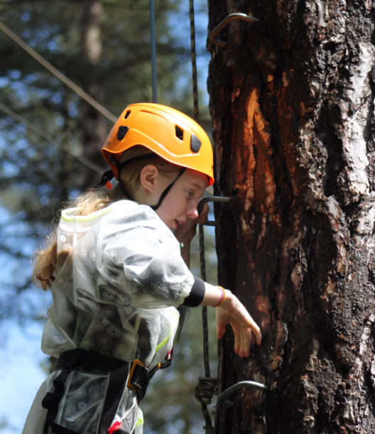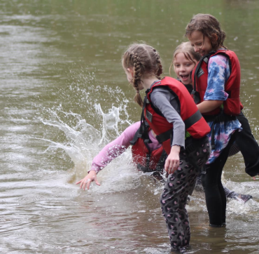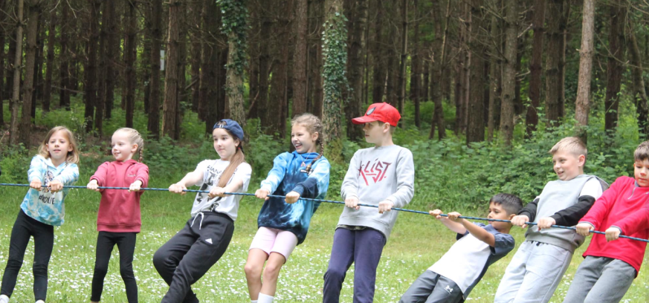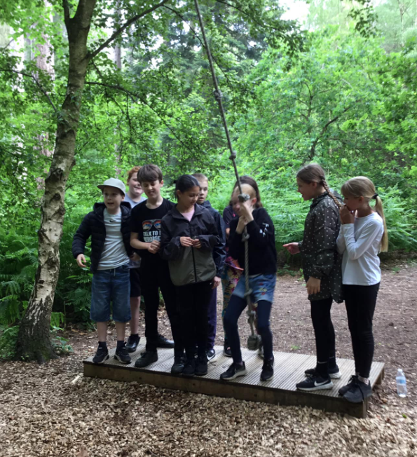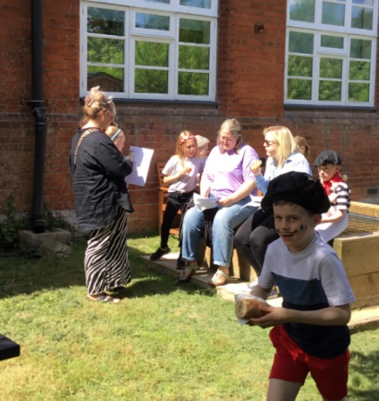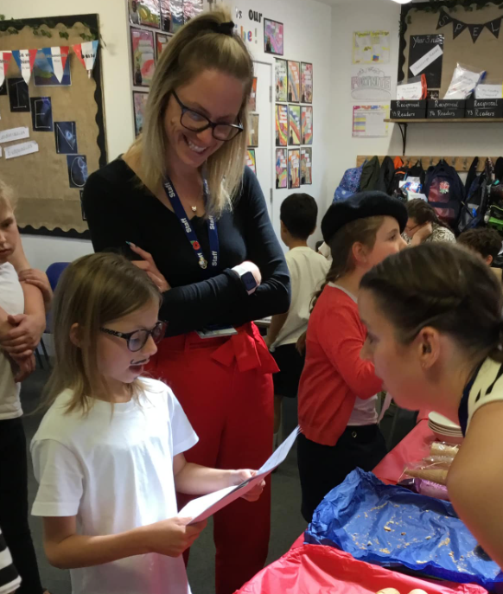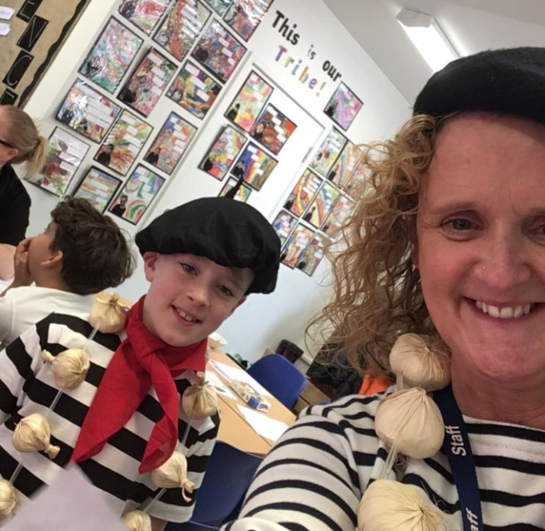

We really enjoyed welcoming so many of you to the parent share sessions. The children were so happy to work with you to practice their French. Thank you to Mrs Maguire and Mrs Harvey for organizing such a wonderful event!

We also had an absolute blast at our school residential at Thorpe Woodlands.

A SNAPSHOT OF THE SCHOOL THIS SUMMER 2nd



**Red Deer**

Red Deer have greatly enjoyed their topic on Inspirational Leaders and have accessed some great learning on Nelson Mandela and Martin Luther King. Come Dine with me was a particular highlight for Red Deer and Parents!

**Badgers**

Badgers have absolutely loved their topic of, ‘Terror on the Titanic,’ this term, with ‘Kaspar Prince of Cats,’ is fast becoming many children’s favourite book. Some beautiful wax drawings have been created by the children!

**Squirrels**

Squirrels have really enjoyed

their, ‘Dinosaurs Roar,’ topic

this half-term and particularly

loved their trip to Roar!

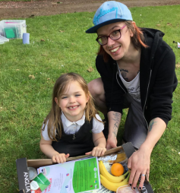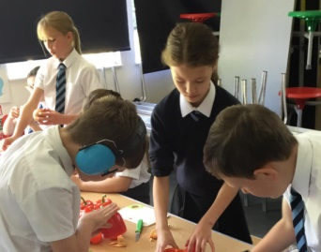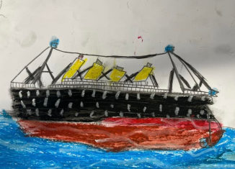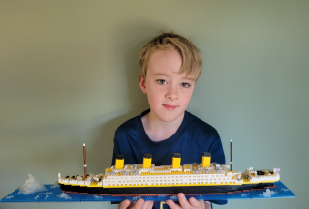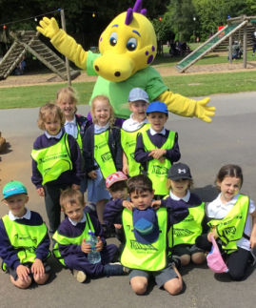

**Last Thing**

Dear Parents,

I want to thank you all for your support of the school over the last academic year. There have been many wonderful events and staff, children and parents have worked tirelessly to keep our school an amazing place to be.

It is with heavy hearts that we will soon be saying goodbye to our Year 6 Leavers’ and we wish them all the success in the world as they transition to high school. They have really lived our core values and are leaving as beacons of: Trust, Hope, Respect and Forgiveness.

We are excited to see you all in September and there are lots of amazing things to look forward to. We hope you have a wonderful summer and are able to relax and connect with your children.

Many thanks,   
Mrs Syer (Deputy Head)

**Foxes**

Foxes have really enjoyed their learning all about the History of Thetford Forest and have loved their books such as, ‘The Owl Who was

Afraid of the Dark.’

Some of the Foxes also enjoyed the,

‘Explore Outdoors,’ sessions,

where they were able to cook

with a parents.

**Dates Reminders:**

* Friday 28th June 2:30-4:30pm: Summer Fete
* Monday 1st July 8:50am: Dress rehearsal at village hall
* Tuesday 2nd July: 6:30pm: Summer Show
* Wednesday 3rd July: Move up Day
* Thursday 4th July 9am: Leavers’ Assembly
* Friday 5th July: Sport’s Day and Colour Run
* Monday 8th July: Southwold Trip
* Tuesday 9th July: High Lodge Trip

**Sad Goodbyes**

We are very sad to be saying goodbye to wonderful Miss Frost at the end of this half-term.

Many of you will agree that she has been a fabulous help and has taught many of the children throughout the year. We wish her all the best and hope she keeps in touch!

**Friendly Reminders:**

In this hot weather, please make sure that your children have got a sun hat, are wearing sun cream and have plenty to drink throughout the day! Also, if we can please remind children to keep off the climbing equipment before and after school as we are uninsured at this time.

A SNAPSHOT OF THE SCHOOL THIS SUMMER 2ND

# Summer 2nd



A SNAPSHOT OF THE SCHOOL THIS OCTOBER

March 2023



At Elveden C of E Primary Academy, we seek to have the highest expectations for our children in their learning and their behaviour. Part of this means ensuring that the children are wearing the correct uniform for the day. One of our expectations is about “Being Ready” and having the correct uniform is part of that. From September, we will be focusing on ensuring the children are in the correct uniform. We appreciate parents support with this.

Our Uniform consists of:

* 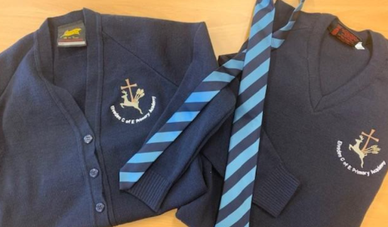Navy jumper/cardigan with school logo
* White shirt for KS2 or polo shirt for EYFS and KS1
* School Tie for KS2 (clip ons only for agreed sensory needs)
* Black grey trousers/shorts/skirt (blue check summer dresses allowed)
* Plain white/ grey/ black socks or tights
* 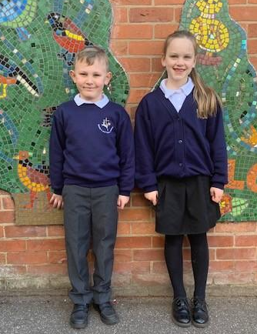Black school shoes (no boots but black trainers that are

ALL black with no coloured markings, black soles and black laces are acceptable)

Our P.E. Uniform consists of:

* Black shorts with elasticated waist.
* Plain black tracksuit bottoms.
* White plain t-shirt.
* Trainers for outdoor P.E.
* Navy blue or black sweatshirt for cold weather

Where to get our uniform…

We hold a small stock of school sweat shirts, cardigans, PE t-shirts, school book and PE bags. Items can also be ordered online at:

A link to this and other uniform infor- mation can be found on our website:

<https://www.elveden.suffolk.sch.uk/web/school_uniform/482395>

We have lots of spare uniform that has been collected by the office available from the school office for a small charge.