**Elveden C of E Primary Academy**

**Spirituality Policy**

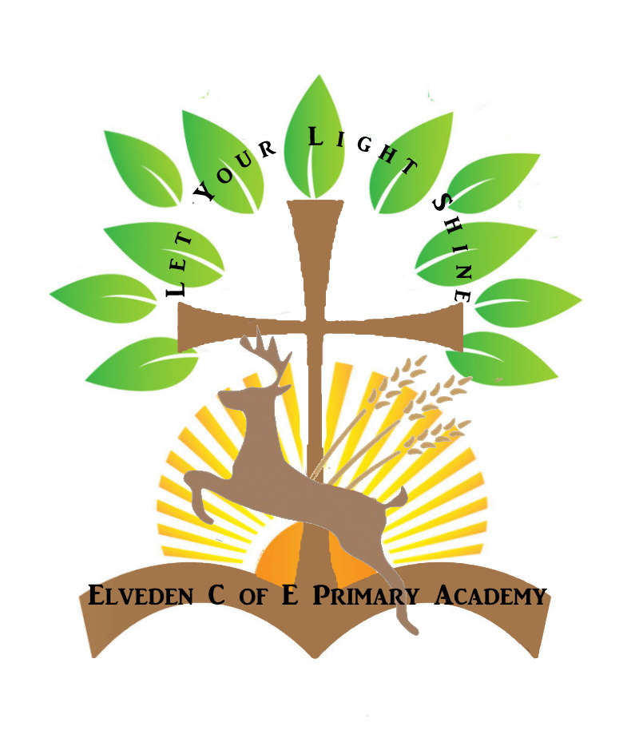

**‘*Let your light shine.’ Matthew 5:16***

Date completed: January 2025

Completed by: Danielle Sanders

Review Date: January 2028

***‘Let your light shine before men’, that they may see your good works, and glorify your Father which is in heaven.’ Matthew 5:16***

**Our Christian Vision**

We celebrate the uniqueness of every child and encourage them to shine before others, in turn giving glory to the heavenly father and preparing them for life’s journey*.*

*‘Let your light shine before men’, that they may see your good works, and glorify your Father which is in heaven.’ Matthew 5:16*

At Elveden C of E Primary Academy we strive for life in all its fullness, for all our children, staff and school community. Elveden is a small, caring Church of England Primary School in Elveden, Suffolk. We are a family community with Christian Values at the heart, where adults and children genuinely care for one another.

* + We **aspire** to be a high achieving school that provides an outstanding education and **culture of opportunity** for all.
  + We believe that every child is unique and valued by God, with their **profound personal development** being at the heart of all we do.
  + We provide a rich and stimulating curriculum that inspires and challenges all to achieve.
  + We foster warm partnerships with parents, the local community, St Andrew and St Patrick’s church and local charities.
  + We teach our children to be excellent Christian role models for the future world.
  + We are inclusive, respectful and celebrate global diversity.
  + We provide excellent care, guidance and support to enable our children to keep themselves happy, healthy and safe in their adult lives.
  + We educate children on the importance of their well-being today and in their future.

**Our Christian Ethos**

Elveden C of E Primary Academy strives to be an inclusive community where children grow, learn and achieve together. Our Building Learning Power Aims, held together by our Christian Values, form the essence of our ethos and gives our school its sense of value and drive. We always challenge our school community to consider what our values mean to them.

Our core values are:

**Hope:** When life’s struggles and storms toss you about, set hope as your anchor. “We have this hope as an anchor for the soul, firm and secure” (Hebrews 6:19, NIV).

**Trust:** “Trust in the LORD with all your heart, and do not lean on your own understanding. In all your ways acknowledge him, and he will make straight your paths.” (Proverbs 3:5-6)

**Respect:** “Do nothing from selfish ambition or conceit, but in humility count others more significant than yourselves.” (Philippians 2:3)

**Forgiveness:** “Jesus gives us the perfect example of forgiveness. While in agony on the cross, Jesus called out, exclaiming “Father, forgive them, for they do not know what they are doing.” (Luke 23:34)

**Perseverance:** “Blessed is the man who remains steadfast under trial, for when he has stood the test he will receive the crown of life, which God has promised to those who love him.” (James 1:12 ESV)

**Friendship:** “Encourage one another and build one another up, just as you are doing.” (Thessalonians 5:11 ESV)

At Elveden C of E Primary Academy we believe that our understanding of society and the world as a whole is at the heart of our school's life. We aim to make it real and meaningful to our children and we recognise the following are fundamental to its achievement:

* That we consider our school society and local community before we reach out to embrace the whole world;
* We commit to creating a school community in which children fully develop in mind, body and spirit through our core values
* Offering a wealth of opportunities and experiences through our culture of opportunity and ambition which provides our pupils with real, memorable activities to support their learning.

To see more of how we approach the Spiritual, Moral, Cultural and Social development of our pupils, please see our **SMSC Booklet and policy** on our school website.

**Rationale**

**What is spirituality?**

Spirituality influences all we do at Elveden C of E primary Academy: it is what breathes life into our whole school community and enables us to live life in all its fullness. Here, spirituality is who we are at our deepest level. It is about our relationships with ourselves, our family, friends, those around us, with God and all of creation.

At Elveden Academy, living out our school vision statement; ‘Letting your light shine’, means we are always giving children opportunities to grow spiritually and become aware of the world in new ways; to wonder about life in all its different facets by incorporating WOW moments of wonder in to our learning experiences.

We also give children opportunities to reflect on their experiences; to meditate on life's big questions and to consider some possible answers. In this they are learning from life by exploring their own insights and perspectives and those of others.

**Our ways in to Spiritual Development**

Liz Mills from The Stapleford Centre, a Christian charity fostering Christian engagement in education, has identified 3 ways that schools can provide opportunities for spiritual development:

WINDOWS: giving children opportunities to become aware of the world in new ways; to wonder about life's 'Wow!s' (things that are amazing) and 'Oh!s' (things that bring us up short). In this children are learning about life in all its fullness.

 MIRRORS: giving children opportunities to reflect on their experiences; to meditate on life's big questions and to consider some possible answers. In this they are learning from life by exploring their own insights and perspectives and those of others.

DOORS: giving children opportunities to respond to all of this; to do something creative as a means of expressing, applying and further developing their thoughts and convictions. In this they are learning to live by putting into action what they are coming to believe and value

We provide WINDOWS throughout our curriculum.by ensuring lessons include an awe and wonder focus by using various stimuli: artefacts, images, videos, music, documentary, stories and real experiences.

We understand that school life can be extremely busy and that it is important for children to have time and space to reflect on life, their own beliefs and values and the world. This is how we incorporate MIRRORS into our curriculum.   There are also times when we need to approach someone who is infinitely wiser and bigger than we are, and our reflective areas are an area where children can do this if they choose to. It allows them to ask and discuss bigger questions and consider their own ideas and beliefs. Through high-quality lessons, children are consistently challenged to reflect on their learning about religion to help them learn from religion, regardless of whether they have a specific faith.

We take care of ourselves, each other, our work and the world we live in, our children identify DOORS for themselves. They are great courageous advocates and actively seek out opportunities to take action by either serving  our local community such as helping to pack donations to take to Ukraine, through fund raising for local and national charities, or  raising awareness through theme days.

Spirituality enables our children to experience life in all it fullness (John 10:10) and ‘Let their Light Shine to bring glory to the heavenly father’.

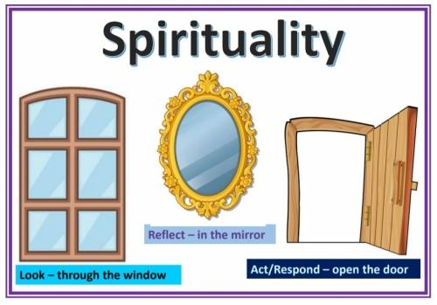

For some, this spiritual experience leads to a sense of transcendence: in other words a feeling or belief that something exists beyond what can be directly seen. Christians would describe this state as God.

Spirituality is a powerful force that determines what we are, and our self-understanding. It forms the basis for successful relationships, and shapes our behaviour and outlook on life, others and the world. Spiritual development relates to that aspect of inner life through which we acquire insight into our personal experiences which are of enduring worth.

At Elveden Church of England Primary Academy our core purpose is profound personal development allied to which our overriding Christian vision is that we strive to deliver on behalf of the children and families we serve to, “Let your light shine.” Matthew 5:16. We strive to help our pupils learn and grow through everything we do whether it is worship, our curriculum, taking part in the activities and opportunities we provide or through the way we relate to each other, our world the way we care for each other. Our Christian values, our sense of the spiritual, our Religious Education provision and our social, moral and cultural education all merge into one, creating our response to life, who we are and who we might be whilst enabling and encouraging all children to grow and flourish spiritually.

It is our aim that the children’s individual spiritual development is fostered as an integral element of the range of learning opportunities and experiences they encounter as part of the curriculum, and that it permeates all strands of school life.

**Aims**

The aims for spirituality at Elveden Church of England Primary Academy are:

* To provide a context of faith, security and loving relationships to support each child’s spiritual search;
* To foster the spiritual development of each child, regardless of age, sex, ability or cultural background;
* To foster self-awareness and promote a feeling of self-worth;
* To develop a set of values, principles and beliefs;
* To develop positive human qualities;
* To develop respect sand empathy for other people and their beliefs;
* To foster respect for people’s feelings and values;
* To develop the children’s enthusiasm to explore and learn through enquiry and first hand experiences;
* To enable the children to attribute meaning to experiences;
* To enable the children to value the non-material dimension of life;
* To foster reflection and stillness;
* To foster a sense of meaning, purpose and direction in life;
* To encourage imagination and creativity;
* To develop a sense of awe and wonder at the miracle of creation, life and the natural world;
* To enable the children to experience a sense of enjoyment and fascination in learning about themselves, others and the world around them, including the intangible;
* To share Christian stories and respond to Christian festivals, rituals and symbols, and that of other religions.

**Organisation and Implementation**

Spiritual development is an important element of a child’s education and fundamental to all other areas of learning.

Without curiosity, without the inclination to question, and without the exercise of imagination, insight and intuition, children would lack the motivation to learn. In view of this, teaching styles at Elveden Academy:

* Value the children’s questions and give them space for their own thoughts, ideas and concerns;
* Enable the children to make connections between aspects of their learning;
* Encourage the children to relate their learning to a wider frame of reference, e.g. asking ‘why?’, ‘how?’, and ‘where?’ as well as ‘what?’.

Spirituality is developed throughout all aspects of school life and is nurtured and promoted as a natural element of the curriculum. Spiritual links are planned for when teachers complete long and medium term plans. The following opportunities will be made available, as an integral part of the school’s practice, in order to facilitate the development of spirituality:

* To explore values and beliefs, including religious beliefs, and the way in which they impact on peoples’ lives;
* Where children already have religious beliefs, to support and develop these beliefs in ways which are personal and relevant to them as an integral part of the school’s practice;
* To engage in enquiry and exploration as part of experiential, first hand learning;
* To look attentively and observe carefully;
* To be creative and imaginative;
* To listen with discernment and respect;
* To reflect and respond to issues in moments of quiet or inspired through music, art, text, film or artefacts;
* To explore and develop what animates themselves and others;
* To understand human feelings and emotions, the way they impact on people and how an understanding of them can be helpful;
* To value what is good and worthwhile and to make value judgements through discussion and exchange of views;
* To work collaboratively with peers, valuing the contribution made by others;
* To respect all, as modelled by staff in their relationships with others;
* To experience silent, calm and tranquil moments which afford time for reflection;
* To work and live in harmony with others in the school and wider community;
* To have confidence to express ideas, views and opinions, even if others do not agree.

Opportunities for spiritual development are presented or naturally arise, and are promoted in all aspects of the curriculum and school life as the children become actively engaged in an enquiry based curriculum, which provides a wide range of experiential learning opportunities that enables them to question, consider, reflect and respond, and consider their own values, beliefs and feelings and those of others, with whom they are working alongside or with.

Outlined below are some of the key ways in which spiritual development is nurtured and promoted as part of the curriculum:

**In English**

* Empathy with authors and the characters in stories and plays;
* The appreciation of beauty in language;
* Emotions and sentiments in writing and speech;
* The value of great works;
* Heroes and heroines in literature;
* Imagining oneself as someone else;
* Escaping into other worlds through literature;
* The element of wonder in literature.

**In Maths**

* Infinity and nothing;
* Pattern and order;
* Shape and regularity;
* Truth, certainty and likelihood;
* The universality of mathematics over time and space;
* The wonder of numbers, formulae and equations.

**In Science**

* Wonder as the basis of science;
* Questions of beginning, creation and evolution;
* Discovering the limits of experimentation;
* Birth, life, death and renewal;
* The universe and beyond;
* Regularity and order in science;
* Beliefs in science and the faith of scientists;
* The impact of scientific achievements.

**In Religious Education**

* People, places, things, books, actions and ideas held by religious believers to be holy;
* Ultimate questions of meaning and purpose;
* Ideas of the divine/questions of God;
* Forms of worship;
* Places of worship and reflection;
* Use of music, art and drama to express beliefs;
* Varieties of beliefs, celebrations and rituals;
* Ideas of commitment and belonging to groups and institutions;
* The idea of mystery and questions with no clear answers.

**In Collective Worship**

* Opportunities for reflection and response are planned into worship;
* Stillness;
* Personal and collective beliefs are respected;
* Sharing and celebrating common beliefs;
* Celebrating success;
* Sharing happiness, sorrow, hurt, excitement, anticipation, fear, etc;
* Common activities such as singing, listening, laughing, praying, reflecting on a theme;
* Remembering and celebrating the lives of people of spiritual significance;
* Emphasising common purpose and values;
* Experiencing emotions.

**In Physical Education**

* Being a team member;
* Pushing yourself to the limits;
* Extremes of skill, endurance and achievement;
* Emotion in sport;
* Personal limitation and failure;
* Appreciation of perfection;
* Sportsmanship.

**In Design and Technology**

* Discovering how something works;
* Appreciating genius;
* Beauty in design;
* Perseverance to solve problems;
* Personal achievement;
* Learning from others and nature.

**In Computing**

* The wonder of worldwide instant communication;
* The speed of the growth of knowledge;
* The accessibility of knowledge and contact with other people worldwide.

**In the Creative Arts (Art, Music, Drama and Dance)**

* The work of creative artists from a variety of times and places;
* Beauty, truth and goodness;
* Expressing, interpreting and exploring deep feelings and profound beliefs;
* Artistic creativity;
* The effects of the arts on emotions and senses;
* The arts as means of expressing mood;
* Skill in creation and performance, and particularly in personal reflection upon their own creativity using various art forms;
* Effects on the emotions and senses;
* Personal response and preference;
* Mood;
* Skill;
* Pattern;
* Formulae.

**In Personal, Social, Health Education (PSHE)**

* Through our Jigsaw curriculum;
* Mindfulness;
* Empathy;
* Discussing emotions and moods;
* Listening to others;
* Reflection;
* Appreciation of self and others;
* Developing resilience;
* Developing and understanding relationships with others and oneself.

**In Geography**

* Wonder at the diversity of environments and people;
* Questions about the care of the environment;
* The beliefs behind particular causes and campaigns;
* World (economic) development;
* Land formation;
* Empathy with people from other parts of the world.

**In History**

* Being in touch with past people, things and ideas;
* Being part of history;
* Handling artefacts;
* Influential events and people;
* The commitment of significant people in history;
* War and peace;
* Interpretation in history;
* The nature and importance of invention and exploration;
* Empathy with people from other times in history.

In addition, as part of the curriculum, the children have opportunities:

* To visit places of beauty, interest and challenge;
* To admire and wonder at the natural environment and human creative efforts;
* To work out personal relationships in unusual and challenging situations;
* To experience community cohesion links at a local, national and global level;
* To engage in charity-based activities;
* To participate in a wide range of events and activities, involving a range of outside agencies, coaches, etc;
* To meet with older adults and share experiences, learning respect from each other (Visitors, Church community, over 60s etc);
* To work with younger children, listening encouraging and caring for them  (Family groups, OPAL, play team leaders, sports leaders);
* To Meet with other people and groups (church visitors, meeting church members, being shown round a mosque/cathedral trip);
* To participate in our school rules and understanding our British Values thread through everything we do at school;
* To take part in open ended enquiry;
* To be involved in democracy and decision making (pupil parliament, young leaders);
* To be committed to courageous advocacy, where the children understand their place in society and that they not only have an important contribution to make towards it but also that that contribution can make a difference. (Elveden Treasured memories)

To see more of how we approach the Spiritual, Moral, Cultural and Social development of our pupils, please see our **SMSC Booklet** on our school website.

In order to facilitate spiritual development, the organisation of the school and the environment for learning are such that:

* Everyone involved in the life of the school is valued and seen to be valued;
* Policies and ensuing practices are clearly seen to reflect the worth of individuals;
* Behaviour and people management policies and practices are collectively written and discussed regularly;
* All adults recognise the need to set good examples of mutual respect and considerate behaviour;
* The quality and nature of the learning environment and displays reflect the value placed on pupils and staff;
* Aesthetic awareness is encouraged;
* The atmosphere of the school welcomes differences in beliefs and values, and invites everyone to belong;
* The achievements, successes and efforts of everyone are recognised and celebrated.

**Assessment**

Spirituality will be assessed as an integral part of classroom practice and the children’s involvement in the life of the school community.

These are areas in which children are expected to grow as part of their spiritual development:

* Reflect on their experiences with increasing sensitivity;
* Question and explore the meaning of experience;
* Understand and evaluate a range of possible reasons and interpretations;
* Develop personal views and insights;
* Apply insights gained with increasing degrees of perception to their own lives in line with the school’s Christian status and history;
* Know that belief is valuable and that the Christian faith is endorsed by the whole school community.

**Monitoring and Review**

Provision for spiritual development is monitored and reviewed by:

* Monitoring of teaching and learning and work scrutiny by RE Lead, PSHE lead, SMSC lead, SLT Head Teacher and governors;
* Pupil voice;
* Discussions at staff and governors meetings;
* Audits of policies and schemes of work;
* RE and Collective Worship monitoring and evaluation.