WELLBEING WARRIORS – MEETING 09.05.2025

Today, we discussed how we can support the well-being of our school community. The Year 6 children in our school have tests next week so we wanted to make them a bag each to make them feel calm and happy. We thought carefully about what we wanted to put in the bags and spent some of our lunchtime decorating them. We decided to put positive affirmations, mindful colouring and some fidget toys in the bags.

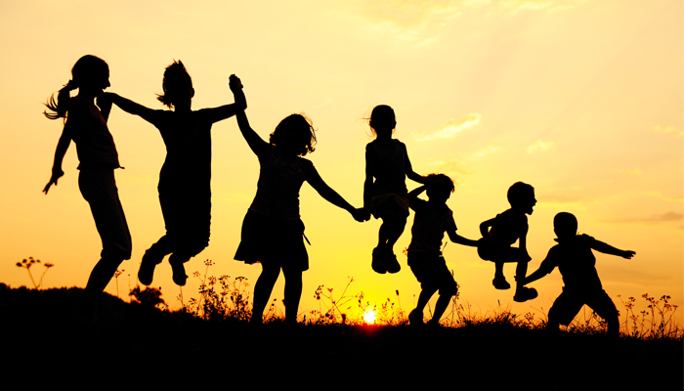

[This Photo](https://territoriodobrincar.com.br/territorio-do-brincar-na-midia/o-poder-educativo-das-brincadeiras-no-desenvolvimento-das-criancas/) by Unknown Author is licensed under [CC BY-NC-ND](https://creativecommons.org/licenses/by-nc-nd/3.0/)