Elveden C of E Primary Academy -Medium Term Plan
Year 2 Transition year - KS1 Cycle A - Autumn 2
“Once Upon a Playground”
W/C | 3rd Nov 25 | 10th Nov 25 | 17th Nov | 24th Nov | 1st Dec 25 | 8th Dec 25 | 15th Dec  (2 days)
 | Week 1 | Week 2 | Week 3 | Week 4 | Week 5 | Week 6 | Week 7
Enrichment | Guy Fawkes/ Bonfire Night |  |  |  | Christingle at church (Fri 5th) | Nativity performance Thurs 11th | Christmas fayre Mon 15th
English Reading | 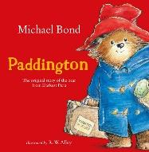  (continued from Autumn 1)  Explain | 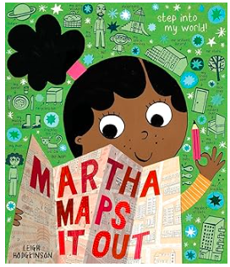  Vocabulary | Retrieval | Sequence | 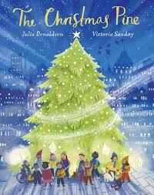  Predict | Infer
English Writing | Strong Start?  Capital letters, finger spaces between words,  Full stops and checking for sense. | Narrative- Stories with familiar settings  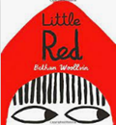  Exclamations  Subordination  Recap – expanded noun phrases | Narrative- Stories with familiar settings | Non-Fiction- Recounts from personal experience  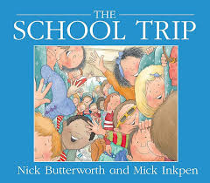  To write in the first person.  To use the simple and progressive past tense. | Non-Fiction- Recounts from personal experience  Write a recount of whole-school trip | Poetry – on a theme (humorous)  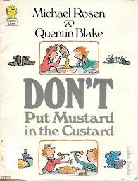  Performing poems  Exploring rhyme  Using a model to create own poem
Maths Yr. 2  (White Rose Maths Scheme) | Number: Addition and Subtraction  Step 15 onwards… | Number: Addition and Subtraction  Step 15 onwards… | Geometry:  Shape | Geometry:  Shape | Geometry:  Shape | ASSESSMENT
NCETM Maths | Yr 2 Week 8 | Yr 2 Week 9 | Yr 2 Week 10 | Yr 2 Week 11 | Yr 2 Week 12 | Yr 2 Week 13
Foundation Subjects
Science:  Animals, including humans (Year 1)  We will identify and name a variety of common animals including fish, amphibians, reptiles, birds and mammals.  We will Identify and name a variety of common animals that are carnivores, herbivores and omnivores.  We will describe and compare the structure of a variety of common animals (fish, amphibians, reptiles, birds and mammals, including pets).  We will identify, name, draw and label the basic parts of the human body and say which part of the body is associated with each sense. | L.O: To be able to Identify, name, draw and label the basic parts of the human body. | L.O: To identify and say which part of the body is associated with each sense. | L.O: To be able to Identify and name a variety of common animals, including fish, amphibians, reptiles, mammals and birds | L.O: To be able to describe and compare the structure of a variety of common animals (birds, fish, amphibians, reptiles and mammals, including pets) | L.O: To be able to Identify and name a variety of common animals that are carnivores, herbivores and omnivores. | Assessment/ Quick Quiz
Geography:  Geography skills and fieldwork  We will be using fieldwork and observational skills to study the geography of the school and its grounds. We will be identifying the key human and physical features in its surrounding areas.  We will devise a simple map of the school and its grounds, using and constructing basic symbols in a key. | L.O. To be able to talk about significant people and events from the past.  I know who Guy Fawkes is.  I can sequence the events of 5th November 1605. | L.O. To be able to use observational skills to identify the human and physical geographical features of the school. | L.O. To be able to use aerial photographs and plans to create a simple map of the school and its grounds. | L.O. To be able to label a map of the school and surrounding area using a basic symbols in a key. | L.O. To be able to use simple compass directions and locational/directional language to describe the location or features in the local area.  To be able to carry out simple fieldwork in the local area. | Assessment / Quick Quiz
DT:  Textiles: Puppets  We will be using materials and sewing skills to make our own puppets. | Lesson 1:  Joining fabrics | Lesson 2:  Designing my puppet | Lesson 3:  Making and joining my puppet | Lesson 4:  Decorating my puppet | Lesson 5:  Evaluating my puppet  Knowledge catcher | Quick Quizzes
Computing:  Digital Writing  (Yr. 1) | Lesson 1:  Exploring the keyboard | Lesson 2:  Adding and removing text | Lesson 3:  Exploring the toolbar | Lesson 4:  Making changes to text | Lesson 5:  Explaining my choices | Lesson 6:  Pencil or keyboard
Music:  Adding Rhythm & Pitch  How does Music tell stories about the past?  (Charanga Y1 MMC) | Nativity  Step 1 Music in my soul (p1) | Nativity  Step 2 Music in my soul (p2) | Nativity  Step 3 Hey friends (p1) | Nativity  Step 4 Hey friends (p2) | Nativity  Step 5 Hello | Nativity  Step 6 Assessment checkpoint
PE:  Ball skills: Hands 1  (Complete P.E y1) - Jamie | Lesson 1: Develop bouncing: Introduce sending with control | Lesson 2:  Introduce aiming with accuracy | Lesson 3:  Introduce power and speed when sending a ball | Lesson 4:  Introduce stopping a ball | Lesson 5:  Develop stopping, combining sending skills | Lesson 6:  Combine sending and Receiving skills
PE:  Dance:  Nativity  (Complete P.E Y1) | Nativity | Nativity | Nativity | Nativity | Nativity | Nativity  Performance  Thursday 11th Dec  morning
PSHE:  Jigsaw (Y1) Celebrating Difference | 1.The same as…  I can tell you some ways in which I am the  same as my friends | 2. Different from…  I can tell you some ways I am different  from my friends | 3.What is ‘bullying’?  I can tell you what bullying is | 4.What do I do about bullying?  I know some people who I could talk to if I  was feeling unhappy or being bullied | 5.Making new friends  I know how to make new friends | 6.Celebrating difference;  celebrating me  I can tell you some ways I am different  from my friends  Quick Quiz/  Assessment
RE:  Judaism  Mitzvat /tzedakah  Why is learning to  do good deeds so  important to  Jewish people?  (Emmanuel Units Y1) | Big Question: Is it important to belong?
 | I am learning to ENGAGE with the concept of a mitzvah or good deed.  and  I am learning to ENQUIRE into how Mitzvot make Jewish people feel they belong to God. | I am learning to EXPLORE (1) mitzvot in a Bible Story. | I am learning to EXPLORE (2) the mitzvah of welcoming a baby girl in the synagogue. | I am learning to EXPLORE (3) the idea of Tikkun Olam in Jewish living | I am learning to EVALUATE my RE learning about the importance of good deeds to Jewish families.  I am learning to EXPRESS my learning so it can be shared with others | Quick Quizzes /Assessment -  Blooms Taxonomy and Assessment grid to fill in.

