Suggested RE Long-term Plan for Church schools: EYFS

Autumn 1 | Autumn 2 | Spring 1 | Spring 2 |  | Summer 1 | Summer 2
Big Question 1 – What does the word ‘God’ mean? | Big Question 2 – Why are some people revered? | Big Question 3 – Is it always easy to help someone? | Big Question 4 -Does everyone need some help? | Big Question 5 –Is every one of us special? |  | Big Question 6 – What is really important to do?
Christian  Creation  Why is the word ‘God’ so important to Christians? | Christian  Incarnation  Why do Christians perform nativity plays at Christmas? | Christian  Salvation  How can we help others when they need it? | Christian  Salvation  Why do Christians put a cross in an Easter garden? |  | Christian  Incarnation  What makes every single person unique and precious? | Christian  Creation  How can we care for our wonderful world?
And encounter a… | And encounter a… | And encounter a… | And encounter a… |  | And encounter a… | And encounter a…
Muslim Birth Rite  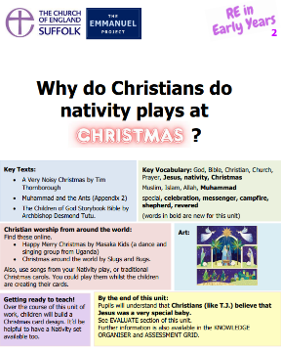  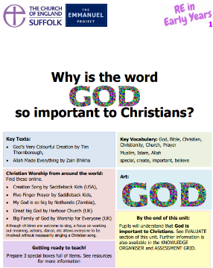  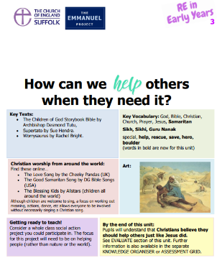  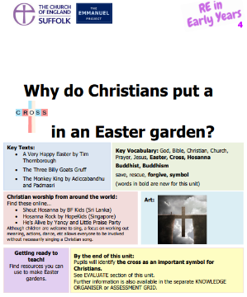  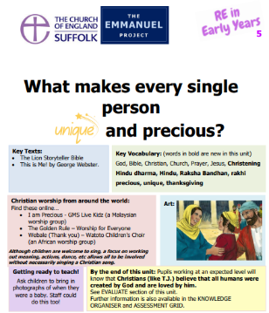  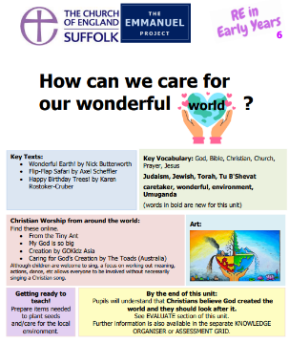  Why do Muslims want to whisper ‘Allah’ in a baby’s ear? | A Muslim Story  For example: Why did Prophet Muhammad rescue some ants? | A Sikh Story  For example: Guru Nanak and the Boulder | A Buddhist Story  For example: What do Buddhists learn from the Monkey King? |  | A Hindu Festival  For example: Raksha Bandhan - How do Hindu brothers and sisters show love? | A Jewish Festival  For example: Tu B'Shevat - Why do Jewish children help plant trees?

Suggested RE Long-term plan for Church schools: KS1
Autumn 1 | Autumn 2 | Spring 1 | Spring 2 | Summer 1 | Summer 2 | YEAR  1  OR  A
Big Question 1 - Is it important to belong? |  | Big Question 2 – Why do people celebrate? |  | Big Question 3 – Should everyone learn to pray? |  | YEAR  1  OR  A
Christian  Church  Why is belonging to God and the church family important to Christians? | Jewish  mitzvot  Why is learning to do good deeds so important to Jewish people? | Hindu  devotion  How does a Hindu celebrate devotion to a deity at the festival of Holi? | Christian  salvation and resurrection  What are the best symbols of Jesus’ death & resurrection at Easter? | Jewish  devotion, creation and tefillah  Why do Jewish families say so many prayers and blessings? | Christian  devotion and worship  Why do Christians pray to God and worship him? | YEAR  1  OR  A
Autumn 1 | Autumn 2 | Spring 1 | Spring 2 | Summer 1 | Summer 2 | YEAR 2 OR  B
Big Question 4: What do people believe is important? |  | Big Question 5: Who is it right to  follow? |  | Big Question 6: Can books and  stories be good teachers? |  | YEAR 2 OR  B
Jewish  salvation and teshuvah  Why do Jewish families talk about repentance at New Year? | Christian  salvation and Saviour  Why was Jesus given the name ‘Saviour’? | Muslim  compassion  How do some Muslims show Allah is compassionate and merciful? | Christian  incarnation and trust  Why do Christians trust Jesus and follow him? | Jewish  Torah  Why is the Torah such a joy for the Jewish community? | Christian  incarnation and parable  What did Jesus teach about God in his parables? | YEAR 2 OR  B

Suggested RE Long-term plan for Church schools: LKS2

Autumn 1 | Autumn 2 | Spring 1 | Spring 2 | Summer 1 | Summer 2
Big Question 1 – Do beliefs make any difference to someone’s life? |  |  | Big Question 2 - What beliefs drive people to make a difference in the world? |  |  | YEAR  3  OR A
Christian  salvation, reconciliation  How do Christians show that reconciliation with God and others is important? | Muslim  devotion, submission  How does a Muslim show their submission and obedience to Allah? | Hindu  karma  Why do Hindus want to collect good karma? | Christian  incarnation, kingdom of God  What do Christians mean when they talk about the Kingdom of God? | Humanist  morality  Why do Humanists use the golden rule as a basis for morality? | Christian  sacrifice  Is the cross a symbol of love, sacrifice or commitment for Christians? | YEAR  3  OR A
Autumn 1 | Autumn 2 | Spring 1 | Spring 2 | Summer 1 | Summer 2
Big Question 3 - What makes some people an inspiration to others? |  |  | Big Question 4 - What beliefs bind a community together? |  |  | YEAR 4 OR B
Christian  salvation  How does believing Jesus is their saviour inspire Christians to save and serve others? | Muslim  prophet  Why do Muslims call Muhammad the ‘seal of the prophets’? | Hindu  dharma  How does the story of Rama and Sita inspire Hindus to follow their dharma? | Christian  body of Christ  Why do Christians call themselves the ‘body of Christ’? | Christian  mission  Why do Christians believe they are people on a mission? | Sikh  equality  How do Sikhs put their beliefs about equality into practice? | YEAR 4 OR B

Suggested RE Long-term plan for Church schools: UKS2

Autumn 1 | Autumn 2 | Spring 1 | Spring 2 | Summer 1 | Summer 2
Big Question 5– Where do people look for answers to life and living? |  |  | Big Question 6 – Are some things more sacred than others? |  |  | YEAR 5 OR A
Christian  salvation and Gospel  Why is the gospel such good news for Christians? | Muslim  devotion and revelation  What does the Qur’an reveal about Allah and his guidance? | Hindu  moksha  What spiritual pathways to Moksha are written about in Hindu scriptures? | Christian  pilgrim  Why do Christians think being a pilgrim is a good analogy for life itself? | Christian  salvation and Eucharist  What is the great significance of the Eucharist for Christians? | Buddhist  enlightenment  How did Buddha teach his followers to find enlightenment? | YEAR 5 OR A
Autumn 1 | Autumn 2 | Spring 1 | Spring 2 | Summer 1 | Summer 2
Big Question 7 – Why are there so many different ideas about God? |  |  | Big Question 8 - What are the best ways to think about death and dying? |  |  | YEAR 6 OR B
Christian  incarnation  How do Christians show their belief that Jesus is God incarnate? | Muslim  tawhid  How does tawhid create a sense of belonging to the Muslim community? | Hindu  Brahman  How do questions about Brahman and atman influence the way a Hindu lives? | Christian  Faith  How do the ‘Heroes of faith’ encourage Christians today? | Christian  salvation and resurrection  Should believing in the resurrection change how Christians view life and death? | Humanist  happiness  Why do Humanists say happiness is the goal of life? | YEAR 6 OR B

