Elveden C of E Primary Academy
Reception/Year 1 Long-Term Plan
Cycle A
 | Autumn 1st  03.09.24 – 23.10.24  7 weeks 3 days | Autumn 2nd  03.11.24 – 16.12.24  6 weeks 2 days | Spring 1st  06.01.25 – 13.02.25  5 weeks 4 days | Spring 2nd  23.02.25 – 27.03.25  5 weeks | Summer 1st  20.04.25 – 22.05.25  5 weeks | Summer 2nd  02.06.25 – 07.07.25  4 weeks 6 days
 | Superheroes! |  | Awesome Animals |  | Pirates of the Sea
Enrichment | Diwali  Fireworks/Bonfire Night  Children in Need |  | Chinese New Year  Mental Health  Safer Internet  Earth Day  Mother’s Day  World Book Day  Red Nose Day  Science Week  Shakespeare Week |  | Father’s Day  World environment day  World ocean day
Trips | Ambulance visit? |  | Zoo trip |  | Sea life center
Provision for growth | Plant cress houses  Plant daffodils |  | Plant tomatoes at the end of term  Plant strawberries |  | Butterfly life cycle  Chick life cycle
Core texts and Literacy | 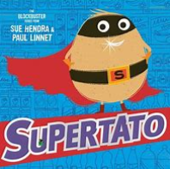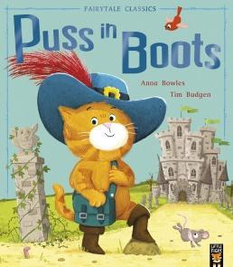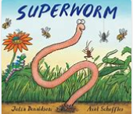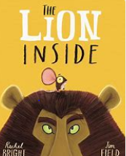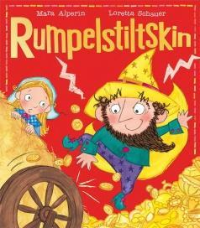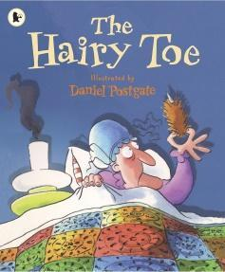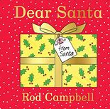 |  | The Missing Teapot  The Bionic Binoculars  The Upside-Down Button  The Pet Popper Upper  The Mini Memory Machine  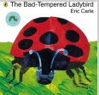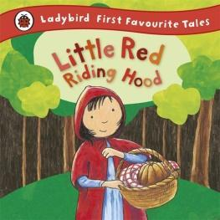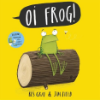 |  | Cheese and Jam  Jump  Ride to Willow Market  The Pizza Tree  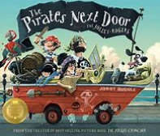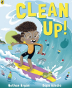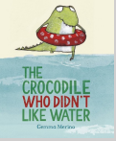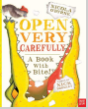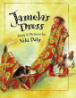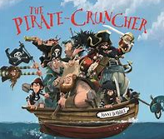
Literacy Reading/  comprehension | Little Wandle phonics
Literacy Writing | 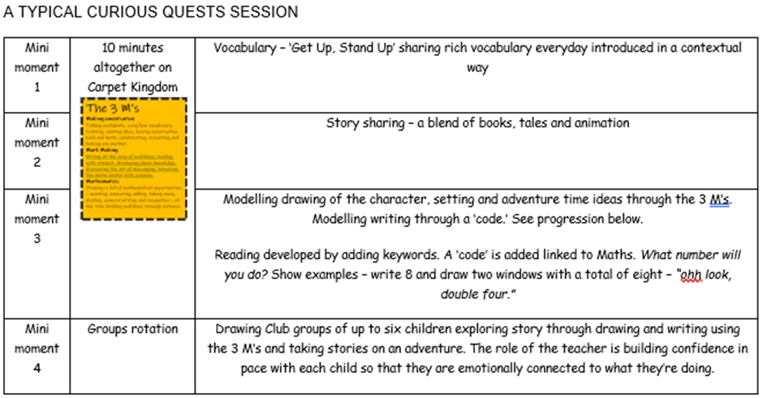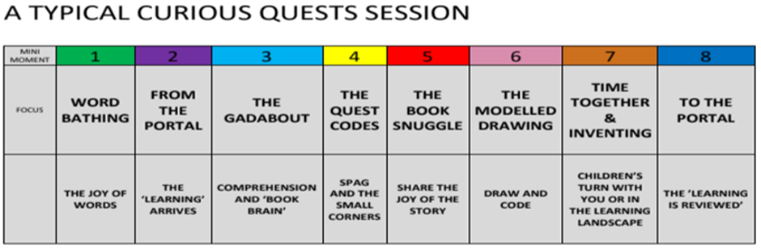
Nursery Rhymes | https://www.bbc.co.uk/teach/school-radio/articles/z4ddgwx  Variety of nursery rhymes to be taught throughout the year
Maths  . | Maths – Maths Mastery programme – Daily work  And  White Rose provision
Understanding the world
Past and Present  History | Drawing ourselves and families, discussing similarities and differences  People who help us, past and present firefighters  Bonfire night – safety and role of firefighters  Studying Great Fire of London, Guy Fawkes/King James 1, Gunpowder Plot, Samuel Pepy’s, making links to past historical events.  Learning the Christas story and own celebrations today. |  | Studying lives of zoologists and what it means to care for animals. (Zoo trip)  History of Edward Newton, a local ornithologist, studying animals that are extinct and changes in their land space over time and what has contributed to their extinction. |  | Studying Christopher Columbus and how he influenced travel and the expansion of the map as we knew it and ‘discovered the new world.’ Sticky learning to study Edward Newton who travelled to Maritius for his studies.
People, culture and communities  Geography  Locational knowledge | Visit from a local hero (ambulance service) explore their job within the community. Studying people who help us and how emergency vehicles have changed over time.  Looking at maps of London during Great Fire and now, comparing changes. Making our own maps for superheroes to save.  Discuss Christmas celebrations, tracking Santa’s journey whilst looking at the world map, oceans, continents. Using the globe to find India and study Hindu celebration of Diwali |  | Studying the United Kingdom and animal native to our country, looking at human and physical features. Looking at animals local to East Anglia and habitats of animals across the world.  Studying extreme weathers and animals from north/south poles and how they survive during the coldest conditions. Studying animals that are important in different cultures and the traditions surrounding them. |  | Studying the globe, learning the name of the oceans and continents. Creating a world map and discuss the weather changes and temperatures of the countries as we go, focusing on the equator. Studying life in other counties, discussing geographical language for each capital city. Studying ships that a pirate crew would travel on, learning names of different parts of the boat and talk about what life would have been like for the pirates on board. Would they like to have been a pirate? What would they have enjoyed?
The Natural World  Plants | Studying the growth of cress and daffodils, weather changes, Autumn season including deciduous/evergreen trees, weather changes  Changes to water and ice as the season moves to winter, discussing weather expectations for the winter season  Studying changing states of matter with freezing water and melting ice, explore natural materials when making hanging decorations at Christmas |  | Studying seasonal changes from winter to spring, weather changes, day light changes, lives of animals during this time – new life  Planting strawberries and tomatoes, observing their growth and ordering life cycles and labelling parts of the plant.  Studying different animal groups and their features, focusing on variety of animals we see at the zoo, including five groups and grouping by what they eat. Making connections to humans being mammals and labelling parts of the human body and connecting to senses. |  | Discussing springtime cycles, ordering the lifecycle of chickens and butterflies, creating life cycles diaries.  Studying the oceans and how the land mass has changed over time, naming oceans and continents and studying different temperatures in the oceans and the wildlife that live there because of this. (Aquarium trip)
Physical Development
PE Unit | Locomotion: Running  Dance: Growing  Ball Skills: Hands 1  Dance: Nativity |  | Ball Skills: Feet  Gymnastics: Wide, Narrow, Curled  Ball Skills: Hands 2  Gymnastics: Body Parts |  | Locomotion: Jumping  Games For Understanding  Team Building  Health and Wellbeing
Expressive Art and Design
Creating with materials  Everyday materials (science) | Making superhero pictures, discussing materials that are safe and most dangerous during fires. Choosing materials to build superhero vehicles and testing them during travel. Creating superhero cities and maps to navigate them, exploring materials that float and sink.  Making Christmas crafts and decorations, acting out the Nativity. |  | Using materials to make paper plate animal masks. Working together to create a collaborative piece of art representing our favourite animals. Create collages using a variety of different materials to show our favourite animals. Using materials to make habitats for our animals; thinking carefully about which materials would be suitable and what their features are. |  | Making textured ocean paintings and mixing colours for hot and cold countries. Using props to act out the lives of pirates on the ship role play. Creating a treasure chest and jewels using suitable materials and developing understanding of floating and sinking and investigate how much treasure can be added to a ‘pirate ship’ before it sinks.
Being imaginative and expressive  Art | Learning songs for Harvest, Remembrance and Christmas and performing in the school Nativity. Using a range of materials to create superhero stage and puppets to use in a performance. Using playdough to create superhero cities to match our designed drawings. Taking part in artist day to learn the skills of a famous artist and apply this to our own replica of their work. |  | Listening to extracts from ‘The Carnival of the Animals’ by Camille Saint-Saëns and talk about which animals we think are being represented and create animal movements to match the music. Designing animal habitats and creating 3D models of animals and a diorama scene using materials and resources of our choosing. |  | Studying a sea-themed painting, discussing the painting and using instruments to respond to different parts of the painting. Learn a selection of new pirate-themed songs and sea shanties like The Pirate Ship Song. Using materials to create pirate pictures while listening to the music.
Personal, Social, Emotional development
Jigsaw-Year 1 unit this cycle | Being Me in my World  Celebrating Difference |  | Dreams and Goals  Healthy Me |  | Relationships  Changing Me
Communication and Language  Listening, Attention and Understanding  Speaking  Year 1-6, not all will be appropriate | Listening and following instructions, responding to ideas, using new vocabulary learning superhero catchphrases and learning rhymes and songs connected to superheroes. Learning ‘Think Big’ to speak in full sentences. Using radios/walkie talkies/phones to use hotlines to call for help from the superheroes and emergency services |  | Listening and following instructions, responding to ideas, using new vocabulary learning animal names and features such as ‘nocturnal’, ‘herbivore’ ‘predator’. Establish ‘Think Big’ and ensure the use of full sentences when speaking. Sharing ideas about favourite animals, learning rhymes and songs connected to animals. Playing themed games; ‘I went to the zoo and I saw a…’ and complete the sentence with the name of an animal. |  | Listening and following instructions, responding to ideas, using new vocabulary. Establishing ‘Think Big’ and the use of full sentences when speaking is consistent. Discussing fiction and non-fiction texts, using past/present tense when discussing the lives of Christopher Columbus and Edward Norton. We will follow written and pictorial clues with a partner to find a treasure chest in the outdoor area. Playing a pirate-themed ‘what if…?’ game, discuss our answers to the ‘what if’ questions, such as ‘What if we found some treasure in the playground?
Religious Education – year 1 this cycle  (Suffolk Agreed Syllabus) | Big Question 1  Is it important to belong?  Christianity – Church  Judaism - Mitzvat  Why is belonging to God and the church family important to Christians?  Why is learning to do good deeds so important to Jewish people? |  | Big Question 2  Why do people celebrate?  Christianity - Resurrection  Hinduism - Devotion  What are the best symbols of Jesus’ death and resurrection at Easter?  How does a Hindu celebrate devotion to a deity at the festival of Holi? |  | Big Question 3  Should everyone learn to pray?  Judaism - Tefillah  Christianity - Worship  Why do Jewish families say so many prayers and blessings?  Why do Christians pray to God and worship him?
Computing
Year 1 this cycle | Project Evolve  Digital Writing |  | Grouping data  Pictograms |  | Moving a robot  Robot algorithm
Forest Schools | Changes – similarities and differences  Comparing environments  Forest rules  Forest art – hanging decorations- using natural resources |  | Making comparisons – sky night and day  Cloud watching  Making dens – how could we keep shaded  Can we make it waterproof? Test |  | Forest rules  Scavenger hunt – size language/ordering  Teamwork – creative make & do
SMSC | Social |  | Moral  Spiritual |  | Cultural

