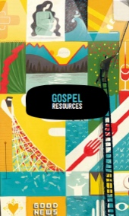
Y5 Gospel
What would Jesus do?

What will we be learning?
- We will be exploring what Jesus described as the two greatest commandments: to love God and to love your neighbour in the parable of The Wise and Foolish Builder (Matthew 7: 24-27) and The Sermon on the Mount (Matthew 5-7)
- We will be thinking about how Christians reflect upon and influenced by Jesus’ Gospel teachings.
- We will be considering how we could learn from Jesus’ teachings. How would “What Would Jesus Do?” affect us in our daily lives?

Key knowledge
- The good news is not just about setting an example for good behaviour and challenging bad behaviour: it is that Jesus offers a way to heal the damage done by human sin.
- Christians see that Jesus’ teachings and example cut across expectations — the Sermon on the Mount is an example of this, where Jesus’ values favour serving the weak and vulnerable, not making people comfortable.
- Christians believe that they should bring this good news to life in the world in different ways, within their church family, in their personal lives, with family, with their neighbours, in the local, national and global community

Key Vocabulary
Parable
Sermon
Things to think about…
How do you use “WWJD” in your daily life?

