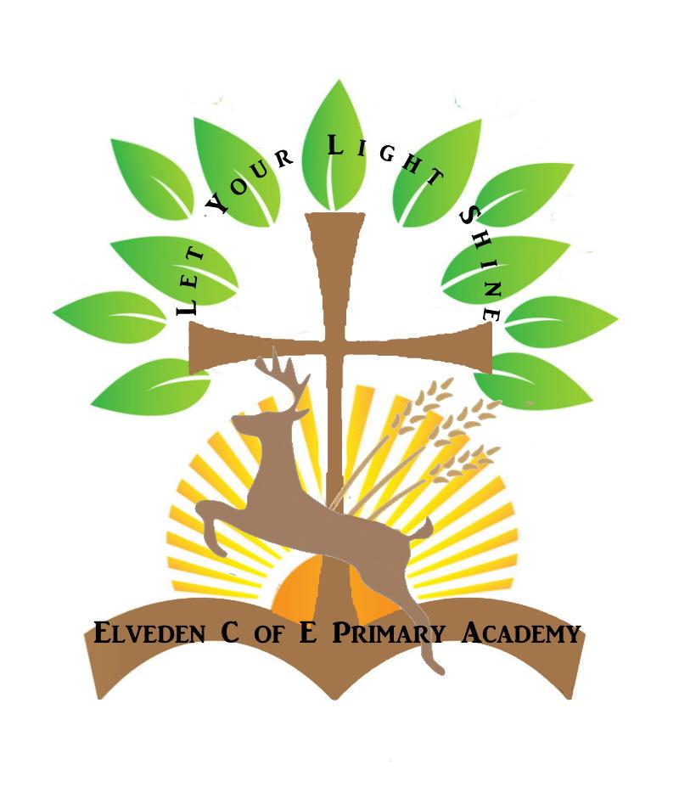
Elveden Academy
Term Dates for Academic Year 2024-25
Autumn 1:
Wednesday 4th September 2024– Thursday 24th October 2024
Autumn 2:
Monday 4th November 2024 – Tuesday 17th December 2024
Spring 1:
Tuesday 7th January 2025 – Friday 14th February 2025
Spring 2:
Monday 24th February 2025 – Friday 28th March 2025
Summer 1:
Tuesday 22nd April 2025 – Friday 23rd May 2025
Summer 2:
Tuesday 3rd June 2025 – Wednesday 9th July 2025
PD Days
- Monday 2nd September 2024 and Tuesday 3rd September 2024
- Friday 25th October 2024
- Monday 6th January 2025
- Monday 2nd June 2025

