Safeguarding Policy
Child Friendly Version
What is this?
Your school has a Safeguarding Policy for staff, families and governors. This ‘child friendly’ policy is designed for young people and this should be read as a guide to the main policy.
What is it for?
To help you decide what could be a ‘problem’ and where to get help and support.
Date Completed: September 2023
Completed by: Mrs Maguire
Review Date: September 2024
Do not keep it a secret!

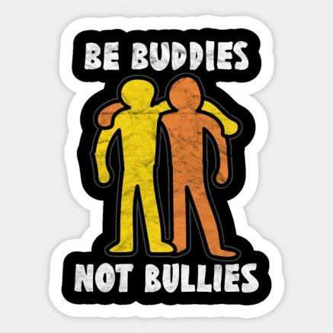
Is someone bullying you?
You must tell someone at school so we can help you. People you can tell are:
- Your teacher
- Your Headteacher
- Any teacher
- Your Teaching Assistant
- Any adult in school
- Play Team
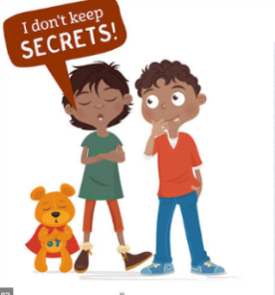
Do not keep it a secret!
Is somebody saying strange things to you that make you uncomfortable or unhappy?
Has someone said something to you or have you heard something that you do not like or upsets you? You must tell someone at school so we can help you.
People you can tell
- Your teacher
- Your Headteacher
- Any teacher
- Your Teaching Assistant
- Any adult in school
- Play Team

Do not keep it a secret!
Is somebody touching you?
Has someone made you feel uncomfortable in how or where they have touched you?
You must tell someone at school so we can help you.
People you can tell are:
- Your teacher
- Your Headteacher
- Any teacher
- Your Teaching Assistant
- Any adult in school
- Play Team
Do not keep it a secret!
Is somebody hitting, punching or smacking you?
Has someone hit, punched, smacked or hurt you in any way?
You must tell someone at school so we can help you.
People you can tell are:
- Your teacher
- Your Headteacher
- Any teacher
- Your Teaching Assistant
- Any adult in school
- Play Team
If in doubt, talk to someone. There are many adults at school for you to talk to and they will help support you.

Do not keep it a secret!
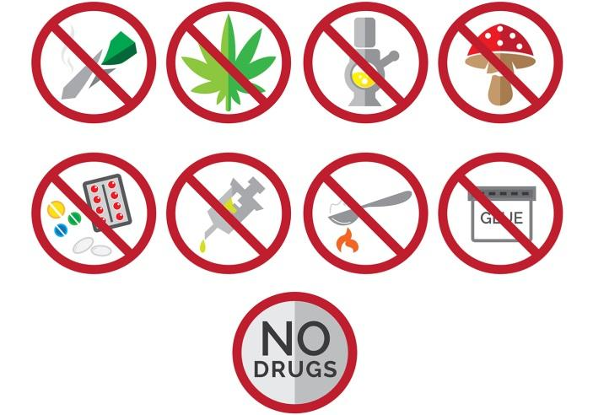
Is somebody giving you tablets, cigarettes, drugs or alcohol?
Has someone asked you if you want a tablet or pill or to smoke a cigarette, or drink something that you do not know what it is? Do not eat, smoke or drink anything if you do not know what it is. You must tell someone at school so we can help you.
People you can tell are:
- Your teacher
- Your Headteacher
- Any teacher
- Your Teaching Assistant
- Any adult in school
- Play Team

Do not keep it a secret!
Online-Safety
Has anyone sent you unkind messages or threatened you? Have you seen anything that has upset or worried you? Has someone on the Internet asked you to do anything that made you feel uncomfortable?
You must tell someone at school so we can help you.
People you can tell are:
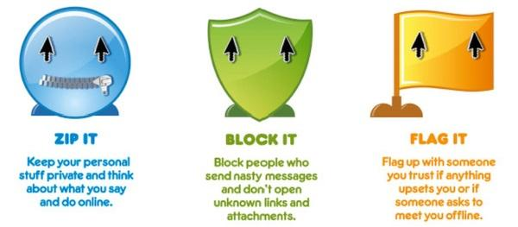
- Your teacher
- Your Headteacher
- Any teacher
- Your Teaching Assistant
- Any adult in school
- Play Team
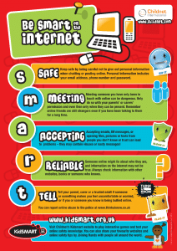
Do not keep it a secret!
Radicalisation and Extremism
A number of young girls and boys have been persuaded to join groups or leave the country against the wishes of their families, or in secret, putting themselves in extreme danger.

What draws people towards extremist ideologies?

- You may be searching for answers to questions about identity, faith, belonging and new ways of life.
- You may be driven by the desire for ‘adventure’ and excitement
- You may be driven by a need to raise your self-esteem and promote your ‘street cred’
- You may be drawn to a group or individual who can offer identity, social network and support.
- You may be influenced by world events and a sense of grievance resulting in a need to make a difference.

Do not put yourself or others in danger!
You must tell someone at school so we can help you.
People you can tell are:
- Your teacher
- Your Headteacher
- Any teacher
- Your Teaching Assistant
- Any adult in school
- Play Team
Do not keep it a secret!

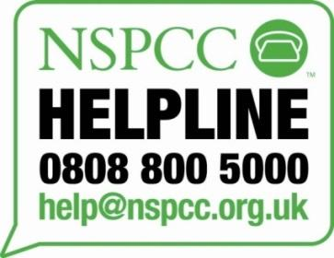
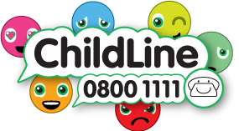

You MUST tell someone! You MUST tell someone!

B Being kind
U Understanding other people’s feelings
D Doing the best you can
D Don’t keep sad feelings to yourself
Y You have the right to be safe and happy
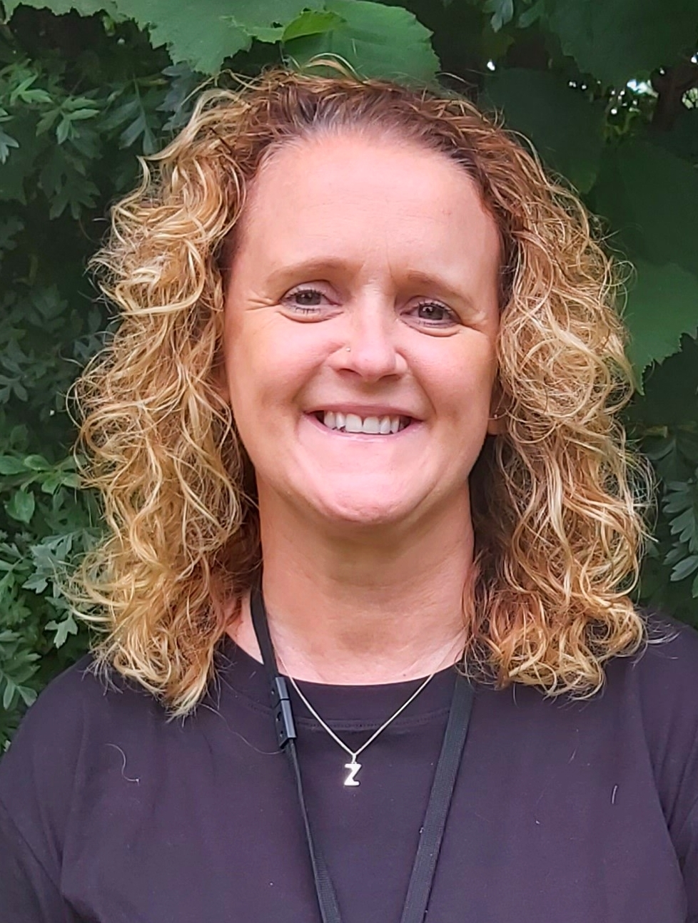
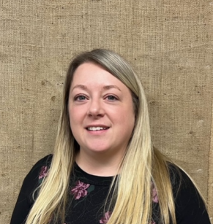
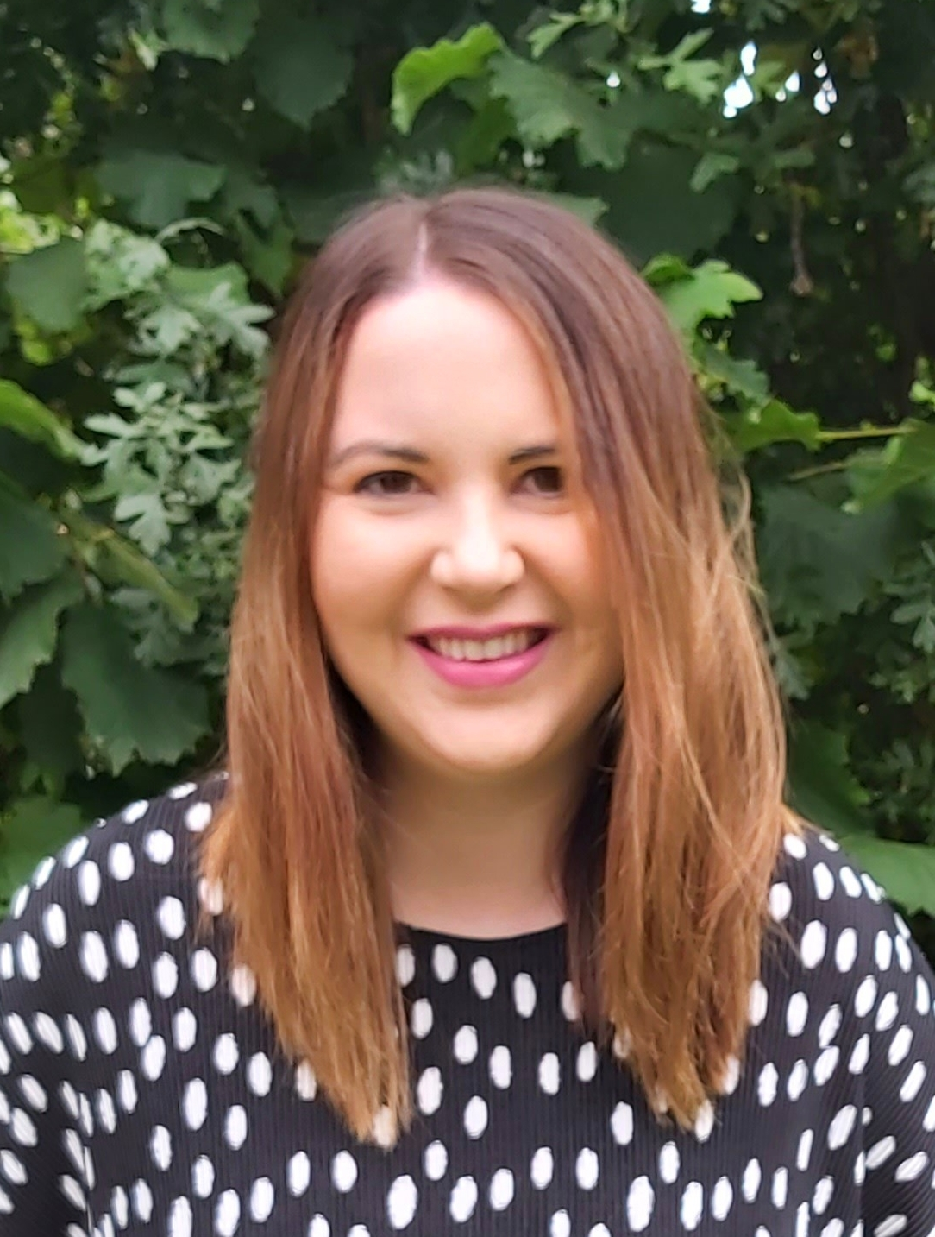
Elveden Academy takes the Safeguarding of their children very seriously. If you have a safeguarding concern you can speak to:
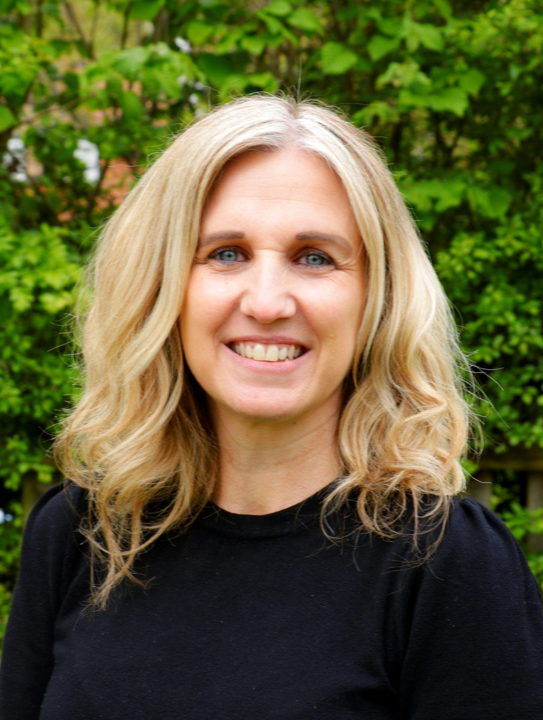 Mrs L Rourke – Headteacher Mrs Anna Syer– Assistant Head Mrs Zoe Maguire- SENCO Miss Sam Goody - Deputy Head

