Key Stage 1— Summer 2nd– Our United Kingdom

|  |  |  |  |  |  |
| --- | --- | --- | --- | --- | --- |
| Week 1: Character Description | Week 2: Character Description | Week 3:  Recount | Week 4: Recount | Week 5:  Activities Week | Week 6: RE Literacy Week-  Rama and Sita: The story of Diwali (Hinduism) |

R.E:

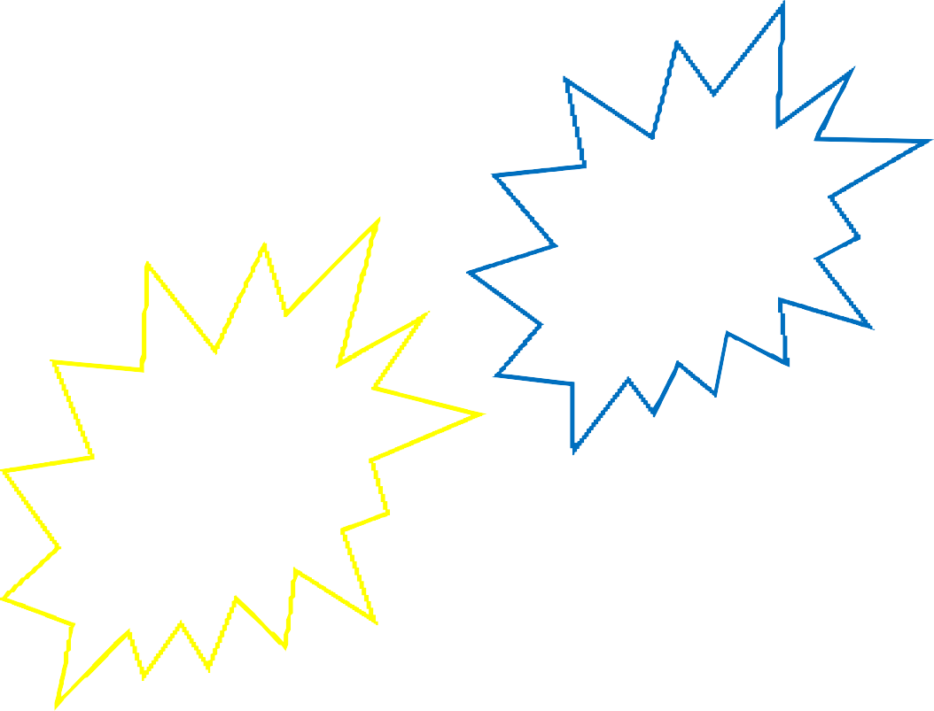

We will be learning about the Torah through Judaism.

# RSHE:

Changing Me Year 1 & 2 (Jigsaw)

Music

We will be learning about Western Classical Music.

(Reflect, rewind and replay-Year 2 Summer 2nd)

PE

# Games (Striking and Fielding)

# Computing:

Presenting Ideas (Unit 2.8)

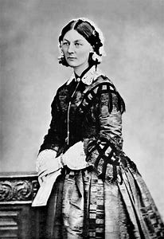

Session 3

L.O: I am learning about Florence Nightingales life.

We will be learning about Florence Nightingales when she arrived at the hospital in Scutari in 1854 and ordering statements of what the hospital was like ‘before’ and

‘after’ Florence arrived.

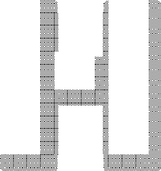

Session 1

L.O: I am learning who Florence Nightin- gale is.

We will be looking through a range of visual clues to see if they can work out what job Florence Nightingale did.



Session 2

L.O: I am learning about Florence Nightingales life.

We will be learning about Flor- ence Nightingales life and se- quencing her life using pictures to create a timeline.



Session 4

L.O: I am learning to identify simi- larities and differences between a medical centre now and in Victori- an times.

We will be looking at pictures of a medical centre now and the hospi- tal ward in Scutari in 1854.

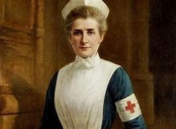

Session 5

L.O: I am learning who Edith Cavell is.

We will be learning about who Edith Cavell is and why she is a significant figure. We will be learning about her job as a nurse.



Session 6

L.O: I am learning to compare nurses

work in the past to today.

We will be comparing nurses today and what it was like when Edith and Florence were alive. We will also be learning why they are significant individuals.

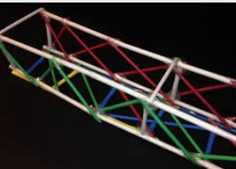

Session 3

L.O: I am learning to select and use tools, skills and techniques to make my product.

We will be making our own bridge us- ing a range of tools.

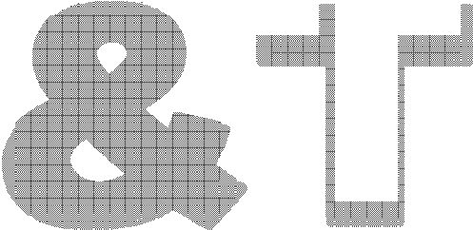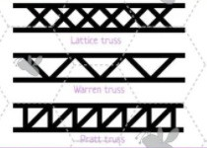

Session 1

L.O: I am learning to generate ideas

based on simple design criteria and ex-

plain what I can make.

We will be looking at different structures of bridges and be discussing what we would like to make.



Session 2

L.O: I am learning to plan my ideas.

We will be discussing how we are going to make our bridges and what we could use. Children will be making a plan and designing their bridge.



Session 4

L.O: I am learning to select and use tools, skills and techniques to make my product.

We will be making our own bridges using a range of tools.

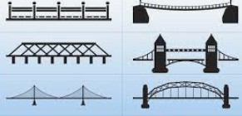

Session 5

L.O: I am learning to evaluate what I have made.

We will be discussing how well our prod- uct works in relation to the purpose, the user and whether it meets the original de- sign criteria.

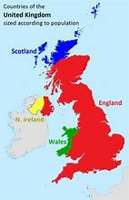

Session 1

L.O: I am learning to name and locate the four countries of the United King- dom.

We will learning about the countries that make up the Unit-

ed Kingdom and they will be playing match- ing games to be able to locate the coun- tries, and name them.

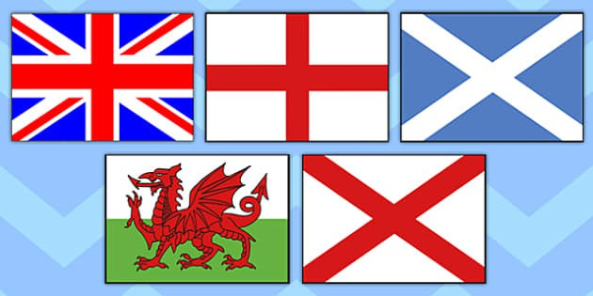

Session 2

L.O: I am learning to name and locate the four countries of the United King- dom.

We will be making our own flags to help us remember all of the countries that make up the United Kingdom.

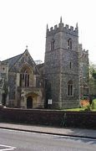

Session 4

L.O: I am learning to understand what my local area is like.

We will be discussing what our local area is called and what we know al- ready about the area. We will be us- ing google maps

to look at im- portant places in the local ar- ea.

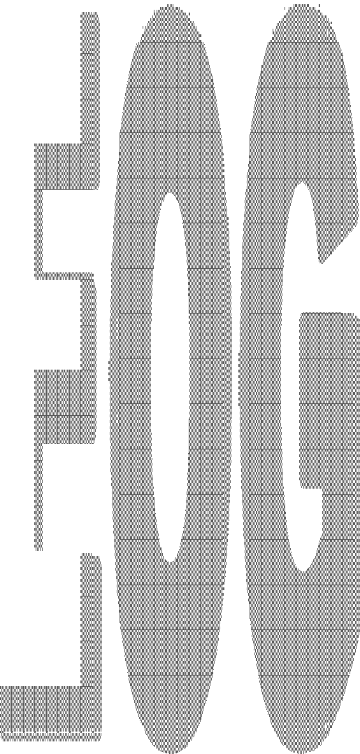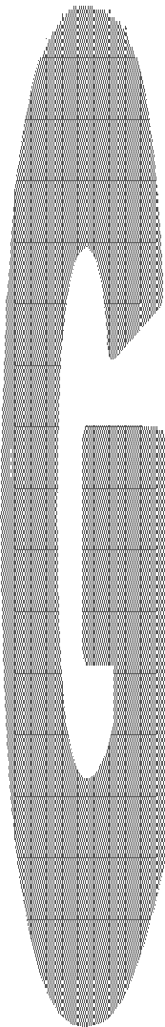

|  |  |
| --- | --- |
|  | |
|  |  |
|  | |
|  |  |
|  | |



Session 4

L.O: I am learning to observe what my area is like.

We will be going on a walk in Elveden and observing what the local area is like.

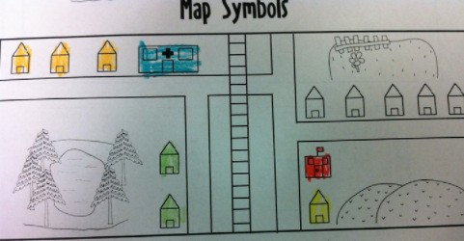

Session 5

L.O: I am learning to describe where things are on a map.

We will be creating our own map of our lo− cal area and adding labels, key and a title.

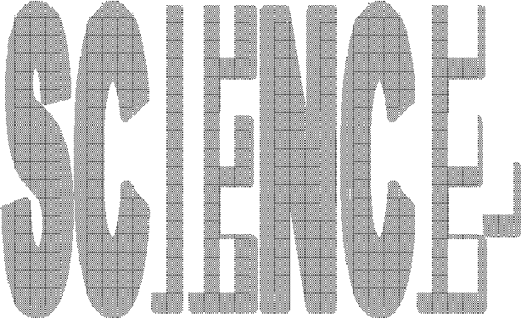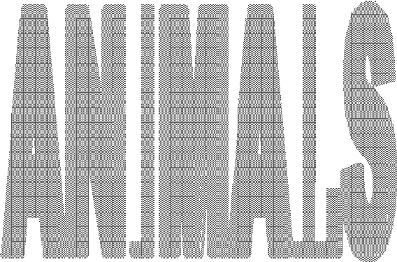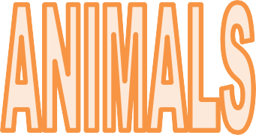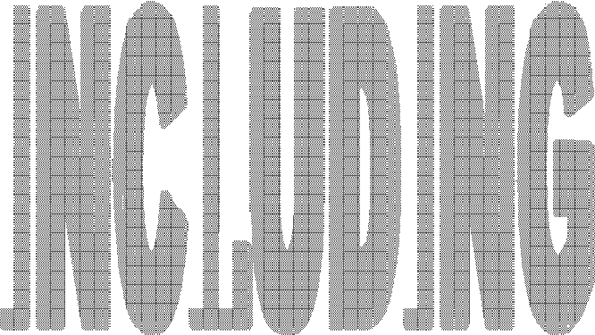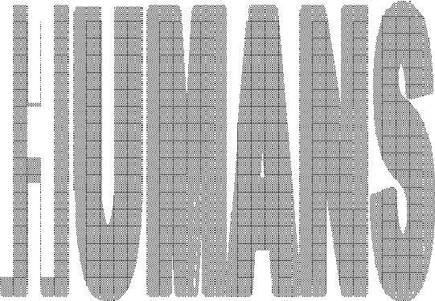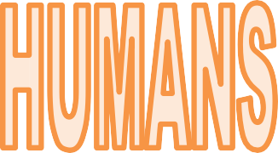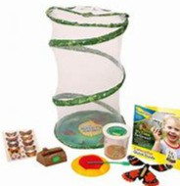

Session 1

L.O: I am learning to notice that animals

have offspring which grow in to adults.

We will be creating our own butterfly garden. We will be observing our cater- pillars at various stages of development and make

predic- tions about fur- ther changes.



Session 2

L.O: I am learning to notice that ani- mals have offspring which grow into adults.

We will continue to observe the cater− pillars over a period of time before they will get

released.

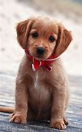

Session 3

L.O: I am learning to find out about and describe the basic needs for ani- mal survival.

We will learning all about what animals

need to survive think- ing about any pets we have at home. We will be recording what we find out.

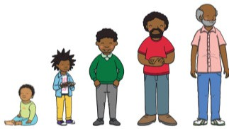

Session 4

L.O: I am learning to notice that ani- mals, including humans, have offspring which grow into adults.

We will be looking at photos of our- selves as babies and compare how we are

now.



Session 5

L.O: I am learning to notice that animals in- cluding humans have offspring which grow into adult.

We will be thinking of questions that we would like to ask someone with a small baby. We will then be ask-

ing questions to our special guest.