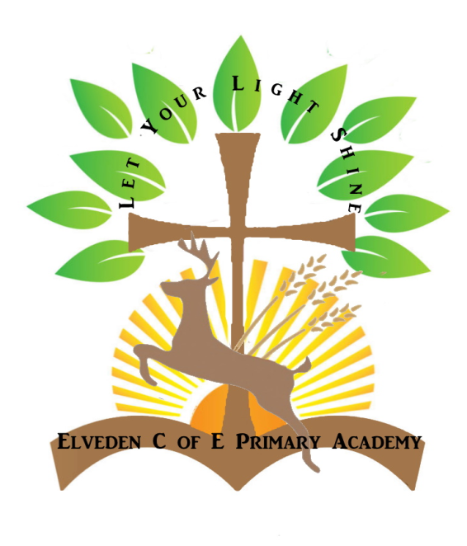 **Elveden’s Amazing Artists Cycle B 2024-25:**

| **Term** | **Artists** | **Style** | **Years established** |
| --- | --- | --- | --- |
| Autumn 1st | Andy Goldsworthy | Natural Sculpture | 1956 - Present |
| Autumn 2nd | Kandinsky | Abstract Art | 1866- 1944 |
| Spring 1st | Giuseppe Arcimboldo | Renaissance/ imaginative painter | 1526 - 1593 |
| Spring 2nd | Salvador Dali | Surrealism | 1904 - 1989 |
| Summer 1st | Yayoi Kusama | Japanese Contemporary Artist | 1929 - Present Day |
| Summer 2nd | Banksy | Street Artist | Present Day |

**Elveden’s Amazing Artists Cycle A 2025-2026:**

| **Term** | **Artists** | **Style** | **Years established** |
| --- | --- | --- | --- |
| Autumn 1st | Edvard Munch  The Scream | Expressionism | 1893 |
| Autumn 2nd | Escher | Graphic Art/ Tessellation | 1898 - 1972 |
| Spring 1st | Giacometti | Sculpture | 1901 - 1966 |
| Spring 2nd | Alma Thomas | Abstract art connected to the natural world. | 1891 - 1978 |
| Summer 1st | Stephen Wiltshire | Cityscape Artist | 1974 - present |
| Summer 2nd | Michael Craig Martin | Contemporary Artist- Everyday objects | 1941 - present |