Key Stage 1— Summer 2nd– A History of Thetford Forest

|  |  |  |  |  |
| --- | --- | --- | --- | --- |
| Week 1:  R.E Literacy Week Sikh Stories-Anita Ganeri  (Sikhism) | Week 2:  Non-Chronological Reports | Week 3:  Non-Chronological Reports | Week 4:  Letter Writing | Week 5:  Letter Writing |

**RSHE:**

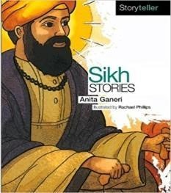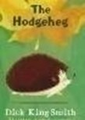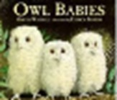

**Music- Charanga**

**Explore sound and cre- ate a story.**

**How Does Music Teach Us About Looking After Our Planet?**

**R.E:**

**We will be learning about blessings through Judaism.**

**PE: Complete P.E Team Building**

**Health and Wellbeing**

**Changing Me (RSE) Year 1 and Year 2**

**Computing:**

**Coding (Unit 2.1)**

  

Session 2: Science

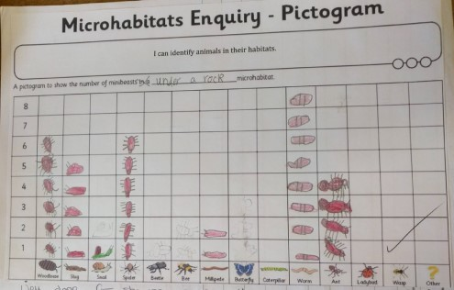

**Session 1: Science**

**LO: I am learning to identify and name a**

**variety of plants and animals in their habitats , including micro-habitats.**

We will then be choosing one habitat to present our findings in a pictogram.

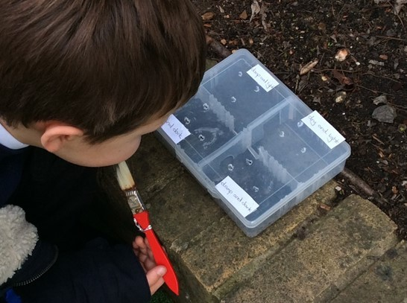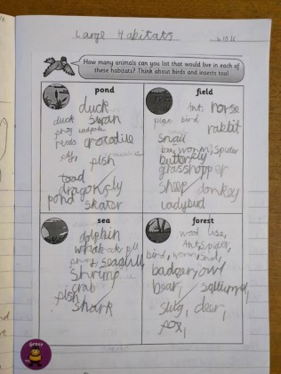

LO: I am learning to identify and name a varie- ty of plants and animals in their habitats,

including micro-habitats

We will be creating a choice chamber to see what habitat the mini-beats prefer.

Session 3 Science

LO: I am learning to identify and name a varie- ty of plants and animals in their habitats,

including micro-habitats

We will be learning about animals that

might live in differ- ent habitats and why they are suited to the habitats.

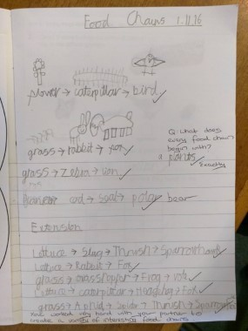

**Session 4: Science**

**LO: I am learning to describe how animals obtain their food from plants and other**

**animals, using the idea of a simple food chain,**

**L.O: I am learning to identify and name different sources of food.**

We will then be learning about food chains and creating our own food

chain pictures.

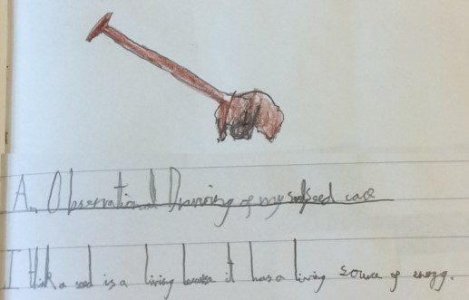

**Session 5: Science**

**L.O: I am learning to explore and compare the differ- ences between things that are living, dead, and things that have never been alive.**

We will collecting some specific objects. We will then sort these objects in different ways. Then, we will be making a careful observation drawing of one of the objects they had found. We will be using a magnifying glass to help

with our drawing.

 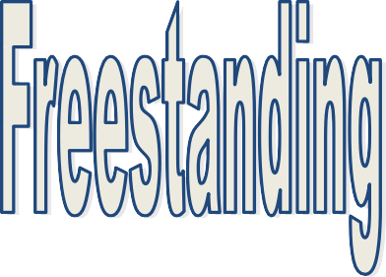 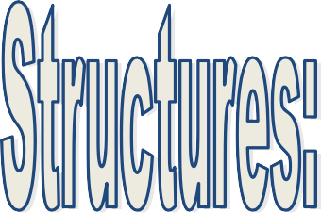 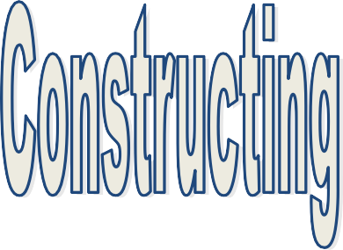

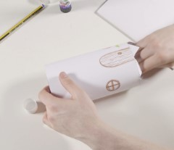

**Session 1: D&T**

**LO: I am learning to design a freestanding structure.**

We will be learning about what a windmill is and constructing a model windmill with refer- ence to the design criteria created for a mouse.

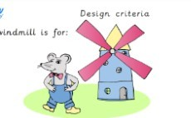

**Session 2: D&T**

**LO: I am learning to make a structure from card, tape and glue .**

We will be decorating our templates and we will construct the main part of our structure follow- ing instructions.. Making sure it stands freely and holds together.

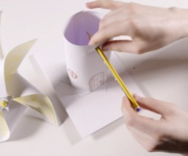

**Session 3: D&T**

**LO: I am learning to make a structure from card, tape and glue.**

We will be competing our turbines by cutting, folding and attaching them to our structures.

We will then test our products strength and stability.

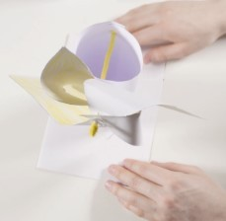

**Session 4: D&T**

**L.O: I am learning to test and evaluate a product and testing whether the structure is strong and stable .**

We will be adding our finishing touches to our wind- mills and testing to

check it will make a suitable home for a mouse. We will be checking if our struc- ture is stable and

altering if not,

 

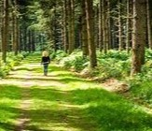

**Session 1: Geography**

**LO: I am learning to locate and name the place where we live and go to school.**

We will be locating and naming the place where we live/go to school (Thetford,

Elveden, England, UK) and the capital city of the UK.



**Session 2: Geography**

**LO: I am learning to recognise Thetford, Elveden from photographs and talk about how we know that other pictures show different**

**places in the UK.**

We will be discussing the physical and human features of Elveden and using the correct vo- cabulary to describe

what is in Elveden. We will be then comparing it to other places in the UK.



**Session 3: Geography**

**LO: I am learning to use four compass points to create maps and use symbols of the forest during fieldwork.**

We will be learning how to use four compass points and using a compass. We will be then creating our

own maps for our local area.



**Session 4: Geography**

**L.O: I am learning what physical and human features we have n our local area.**

We will be adding to our maps by investigating & identifying what physical and human fea-

tures we have in our local area– This will be an opportunity for fieldwork.

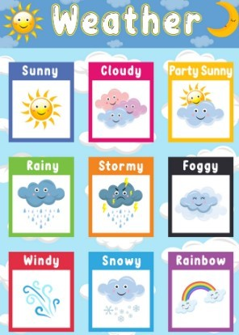

**Session 5 Geography**

**LO: I am learning to identifying seasonal and daily weather patterns in the UK and hot and cold plac- es in the world.**

We will be looking at daily weather patterns in the UK. Then we will be looking and comparing to hot and cold places in the world.

 

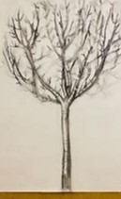

**ART- Observation Drawings**

**L.O: I am learning to observe and record the shapes, patterns and textures found in objects.**

**L.O: I am learning to investigate tone by drawing light/ dark lines, light/dark patterns, light/dark shapes using a pencil.**

On our trip, we will be observing what we can see and creating observational drawings of the forest. We will be looking at investigating tone using a pencil.

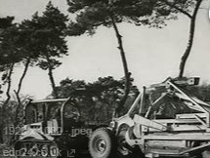

**HISTORY- Significant Events in Local Area**

**L.O: I am learning about the history and heritage of Thetford Forest since 1922 to present day.**

On our trip, we will be using the information at High Lodge (Thetford Forest) to find out about the past. We will use

the information to ask questions and find answers to ques- tions about the past.



We will also be using what we have been learning in our Geography lessons

while we are on the trip. We will be using a compass to get around the forest in groups.