Key Stage 1— Autumn 2nd– Guilty Guy Fawkes

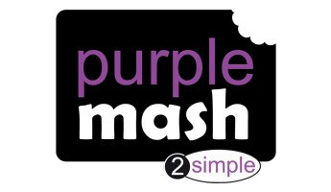

RSHE:

R.E:

Celebrating Difference

We will be learning about good deeds

through Judaism.

(Jigsaw YR 1)

PE:

Computing:

Dance

Ball Skills

Lego Builders (Unit 1.4), Technology

outside of school (Unit 1.9) & Grouping and Sorting (Unit 1.2)



Music- Charanga

Adding Rhythm and Pitch (Year 1 Aut 2nd)

Nativity

|  |  |  |  |  |  |
| --- | --- | --- | --- | --- | --- |
| Week 1: | Week 2: | Week 3: | Week 4: | Week 5: R.E Literacy Week | Week 6: |

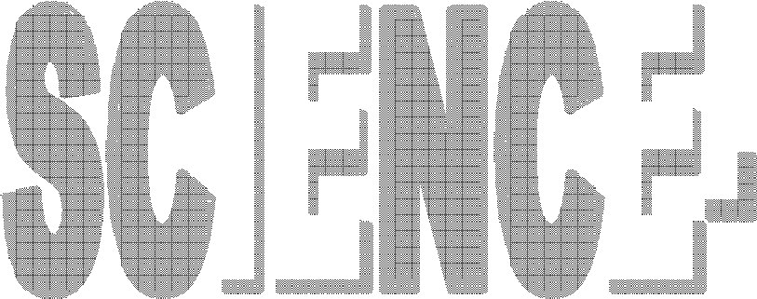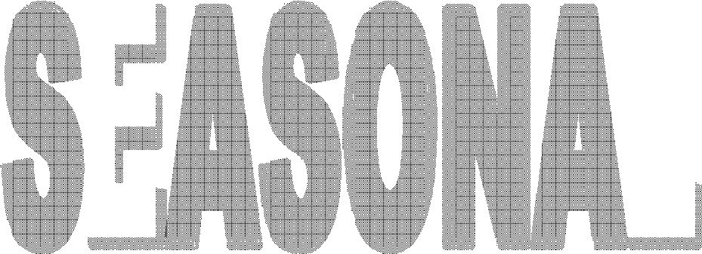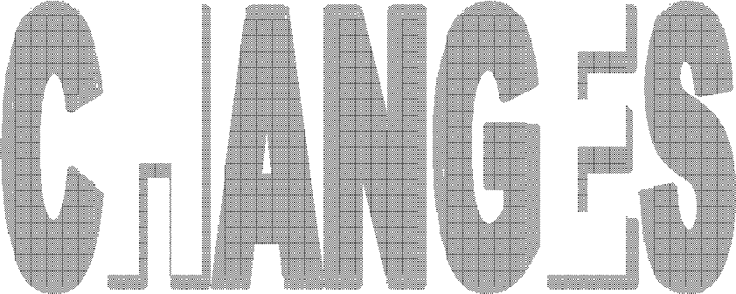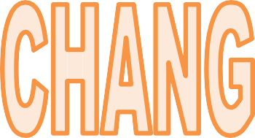

Session 1: Science

LO: I am learning to observe changes across the four seasons.

We will be going on a nature walk and observing the changes that are happening. We will be comparing the leaves on the ground and those still on plants.

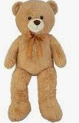

Session 2: Science

LO: I am learning to observe how day length varies.

We will be taking it in turns to take Barry Bear home each day and then record what we did with him and Barry Bear needs to go to bed when it gets dark. We will be documenting the time it gets dark..

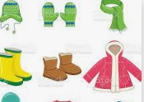

Session 3: Science

LO: I am learning to observe and describe weather associated with the seasons.

We will be discussing what clothes we need to wear in winter and we will be giving reasons for this.



Session 4: Science

LO: I am learning to observe changes across the four seasons.

We will be going on a nature walk and observing the changes that are happening. We will be comparing the leaves on the ground and those still on plants.

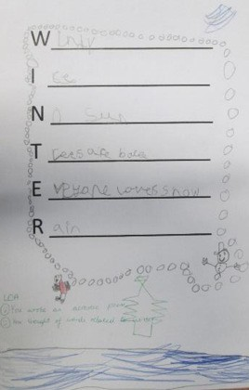

Session 5 : Science

L.O: I am learning to observe and describe weather associated with the seasons.

We will be creating class mind maps for each season and discuss what we have learnt. We will then write winter poems.



Session 6: Science

L.O: I am learning to observe and describe weather associated with the seasons.

We will then write a letter to Olaf to tell him about the other seasons that he has not experi- enced from what we have been learning about the other seasons.

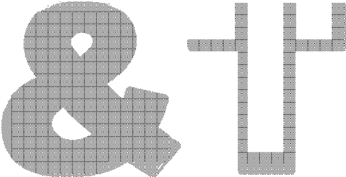

Session 2: Making

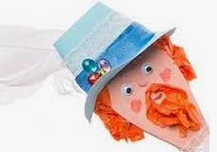

Session 1: Designing

LO: I am learning to design a functional and appealing product for a chosen user and pur- pose based on simple design criteria.

We will be designing our own Guy Fawkes pup-

pet.

L.O: I am learning to select from and use a range of tools and equipment to perform practical tasks such as marking out, cutting, joining and finishing.

We will be selecting the tools we need and will start to make our product.

Session 3: Making

L.O: I am learning to select from and use a range of tools and equipment to perform practical tasks such as marking out, cutting, joining and finishing.



We will be selecting the tools we need and will start to make our product.



Session 4: Evaluating

LO: I am learning to evaluate their ideas throughout and their final products against original design criteria. .

We will then look at our products and think

what we would do differently next time.

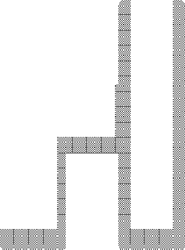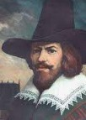

Session 1:

LO: I am learning to develop an awareness of the past and identify similarities, including differences between ways of life in different periods.

We will discuss a picture of Guy Fawkes and

learn key information on him. Then we will look at the range of objects for the children to think about which would have been available for Guy Fawkes to use in 1605.



Session 2:

LO: I am learning to find out about events beyond living memory that are significant nationally.

We will discuss how they think the plotters decided to solve the problem of getting their gunpowder barrels into the

Houses of Parliament. We will then have a go at role playing what the plotters might have spoken about.

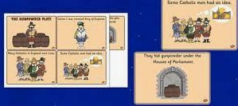

Session 3:

LO: I am learning to find out about events beyond living memory that are significant nationally.

We will be ordering the events of the gun pow-

der plot.

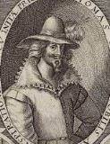

Session 4:

LO: I am learning to ask and answer questions, choosing and using parts of stories and other sources to show that they know and under- stand key features of events

We will think of questions to ask Thomas Percy, such as: How will you

avoid getting caught? How are you feeling? What will you do now? We will then complete a hot seating activity.



Session 5 :

L.O: I am learning to find out about events beyond living memory that are significant nationally.

We will be in six groups and each group will have a part of the story that they are going to act out. We will be using our knowledge of what we have

learnt so far.



Session 6 :

LO: I am learning to find out about events beyond living memory that are significant nationally

We will look through and discuss the images of bonfire nights from the past and ask questions such as How can you tell that this is happening in the past? What

is different? We will talk about our own experience of bonfire night.

|  |  |
| --- | --- |
|  | |
|  |  |
|  | |
|  |  |
|  | |

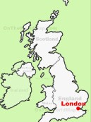

Session 1:

LO: I am learning to use world maps, atlases and globes to identify the United Kingdom and its countries .

We will be locating London on a map. We will discuss where we live

and where this on a map of the United Kingdom.

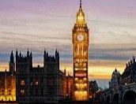

Session 2:

L.O: I am learning to use aerial photographs and plan perspectives to recognise land- marks .

We will be learning about famous London land- marks today and we will look at aerial photo- graphs of them.

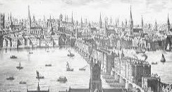

Session 3:

L.O: I am learning to aerial photographs and

plan perspectives to recognise landmarks .

We will be going back in time to look at pictures of London in the 1500’s. We will be comparing it to London today.

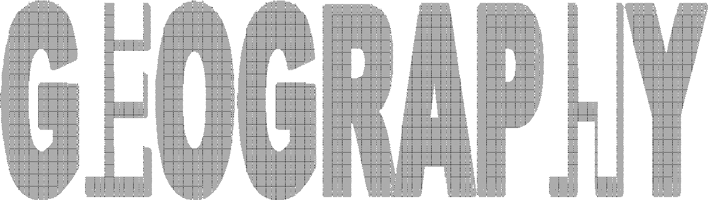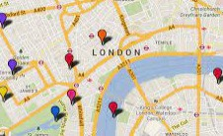

Session 4:

LO: I am learning to devise a simple map.

We will be drawing a simple map of London in

the 1500’s.