Key Stage 1— Spring 1st– Venturing Victorians



R.E:

We will be learning about gospel through Christianity.

Music- Charanga

Introducing Tempo and Rhythm

How does Music make the world a better place?

PE:

Ball Skills: Feet

Gymnastics: Wide,

|  |  |  |  |  |  |
| --- | --- | --- | --- | --- | --- |
| Week 1: Nonsense Poetry | Week 2: Nonsense Poetry | Week 3: Extended Stories | Week 4: Extended Stories | Week 5:  Fairytales and Traditional Tales | Week 6:  Fairytales and Traditional Tales |

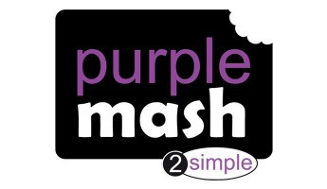

RSHE:

Dreams and Goals (Jigsaw YR 1)

Computing:

Creating Pictures (Unit 2.6)



|  |  |
| --- | --- |
|  | |
|  |  |
|  | |
|  |  |
|  | |

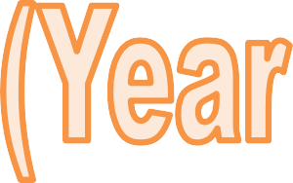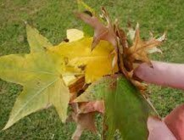

Session 1: Science

LO: I am learning to identify and name a varie- ty of common wild and garden plants, includ- ing deciduous and evergreen trees.

We will explore the school grounds and we will look at the plants. We will look at the leaves which have fallen on to the floor.



Session 2: Science

LO: I am learning to identify and name a varie- ty of common wild and garden plants, includ- ing deciduous and evergreen trees.

We will go on a ‘leaf’ hunt and collect leaves. We will observe what they look like. We will start to explore the vocabulary deciduous and evergreen trees.

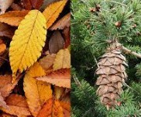

Session 3: Science

LO: I am learning to identify and name a varie- ty of common wild and garden plants, includ- ing deciduous and evergreen trees.

We will be writing up what we have found out about deciduous and evergreen trees. We will be seeing if we can

spot any trees and find out whether they are deciduous and evergreen trees.

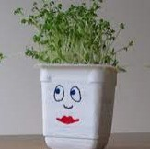

Session 4: Science

LO: I am learning to identify and describe the basic structure of a variety of common flower- ing plants, including trees.

We will be planting our own seeds. We will be observing them and writing up our own diary of our plants.



Session 5 : Science

LO: I am learning to identify and describe the basic structure of a variety of common flower- ing plants, including trees.

We will be planting our own seeds. We will be observing them and writing up our own diary of our plants.

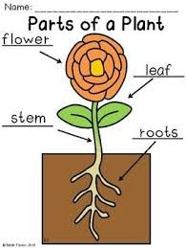

Session 6: Science

LO: I am learning to identify and describe the basic structure of a variety of common flower- ing plants, including trees.

We will be drawing our own plant and labelling the structure of the plant using our key vocabu- lary.

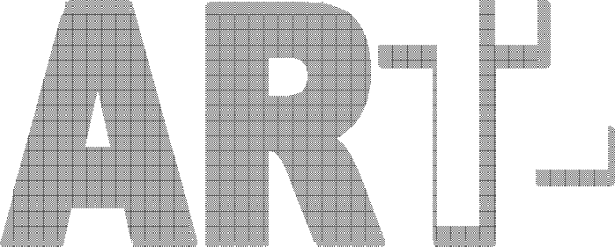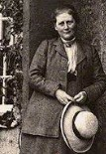

Session 1: ART

LO: I am learning about an artist.

We will be learning about who Beatrix

Potter is. We will create our own fact files.

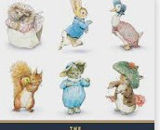

Session 2: ART

LO: I am learning about an artist.

We will be exploring some of Beatrix Potters drawings. We will be exploring what media she used to create her draw- ings.

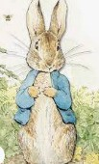

Session 3: ART

LO: I am learning to representing familiar ob-

jects as a ‘schema’ by combining shapes.

We will be drawing ‘Peter Rabbit’ using a step by step guide to

help us. We will be sketching our outline first.



Session 4: ART

LO: I am learning to experiment with a variety of media.

We will be adding colour to our ‘Peter Rabbit’ drawing and add extra details. We will be experimenting with a variety of media: pencils, rubbers,

crayons, pastels, felt tips, charcoal, pen and chalk.

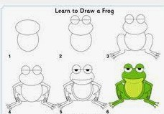

Session 5 : ART

L.O: I am learning to draw confidently from imagination.

We will be drawing our own animal char- acters and adding key details looking closely at pictures to help us.



Session 6: ART

L.O: I am learning to add detail to my artwork.

We will be adding colour to our own ani- mal drawings. We will explore a range of medias to use to create our masterpiece.

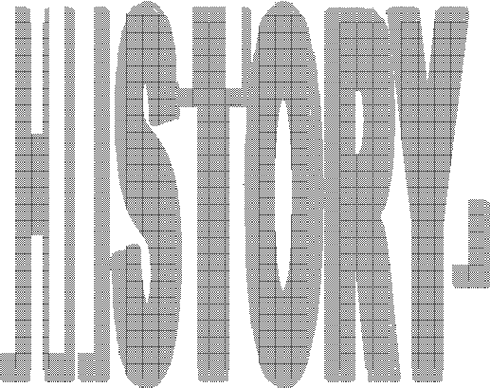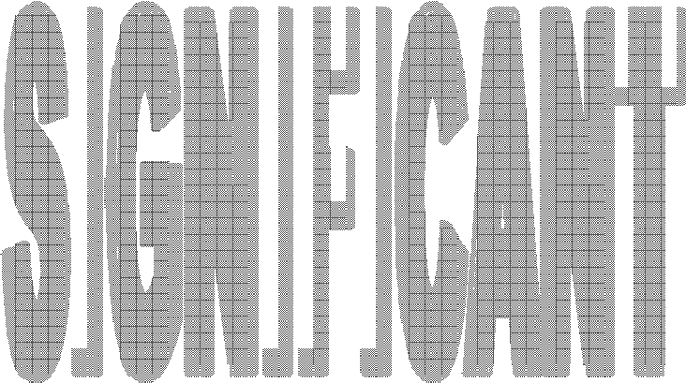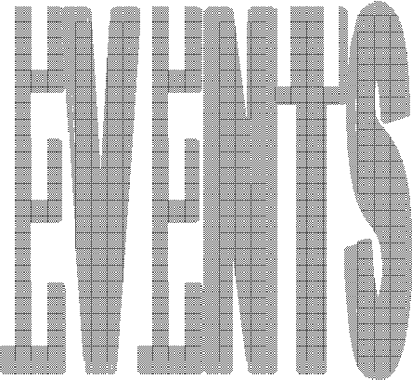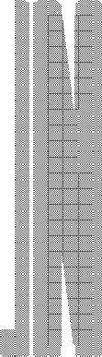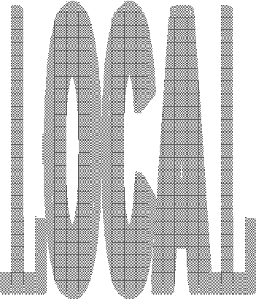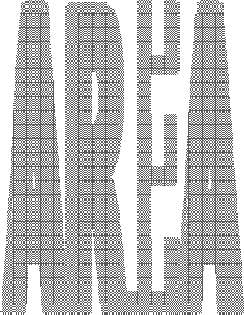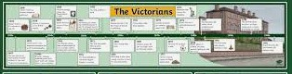

Session 1: History

LO: I am learning to label time lines with words or phrases such as: past, present, older and newer.

We will be looking at a timeline and ex− ploring when the Victorian Era was. We will be looking at the key vocabulary of past, present, older and newer.

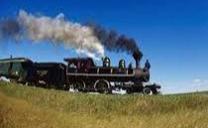

Session 2 History

LO: I am learning about significant events in our local area.

We will be learning about Steam transport. We will be exploring what it is and why it was so important in the Victorian Era.

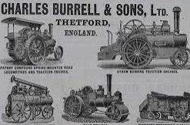

Session 3: History

L.O: I am learning about significant events and people in our local area.

We will be learning about who Charles Burrell is and the work that he did. We will be creating a fact file on him.



Session 4: History

LO: I am learning to ask questions.

We will be preparing questions that we would like to ask about Charles Burrell and his life for when we visit the Charles Burrell Museum.



Session 5 : History (TRIP)

L.O: I am learning to use artefacts, pictures, stories, online sources and databases to find out about the past.

We will be going on a trip to the Charles Burrell Museum to learn more infor- mation about steam transport.

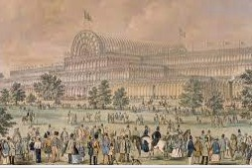

Session 6: History

L.O: I am learning to use artefacts, pictures, stories, online sources and databases to find out about the past.

We will be learning about the Great Exhibi- tion and learning about how Britain cele- brated the work of great inventors.