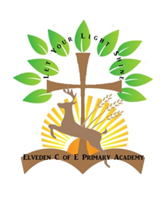**Elveden Achievers Magazine**

Nominate a Child to be in the Elveden Achievers Magazine:

All members of the school community are invited to make nominations for the Achievers Magazine which is not just for our children, but can be staff, parents and members of the wider community. The magazine is published each term and we also celebrate these successes in our Friday Celebration Assembly.

We also encourage our Parents to nominate children’s acts of selflessness and courageous advocacy so please fill in the forms on the website and hand in to Mrs Sanders. Photos should be emailed to the office, or children are welcome to bring in any trophies/certificates for Mrs Sanders to take their photo in school.