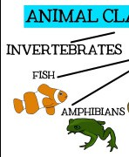

Session 5: Science– Animal groups

L.O: I am learning to describe and compare the stru common animals (fish, amphibians, reptiles, birds a pets).

We will explore fish, amphibians and reptiles and see which animals go into which group. The children will complete a sorting activity using pictures and small world animals.

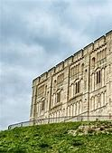

Session 8: History

L.O: I am learning to recognise significant historical p

Children will be exploring Norman life and castles in more detail.

They will be drawing castles and labelling what each feature is for.

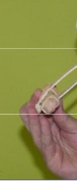

Session 11: D&T

L.O: I am learning to select from and use a range of to

perform practical tasks.

Children will then be making their catapult sign.

Key Stage 1— Autumn

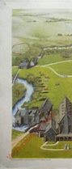

Session 2: Geography

L.O: I am learning to describe the physical features The children will receive a letter from

the Duke of Normandy asking class to build a new castle. The children will need to investigate where the castle should be built and why.

|  |  |  |  |
| --- | --- | --- | --- |
| Week 1: | Week 2: | Week 3: | W |

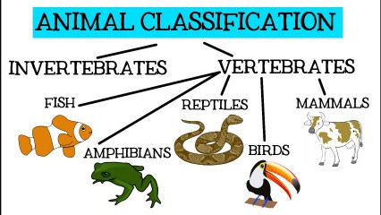

Session 1: Science—Animal groups

LO: I am learning to identify and name a variety of common animals including fish, amphibians, reptiles, birds and mammals.

This is an introduction into animal groups. Children will use small world animals to explore what groups the animals go in.

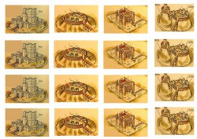

Session 4: History

L.O: I am learning to recognise historical places in locality.

Focus on wooden castles (such as Mountfitchet Castle) and compare them to stone castles (such as Norwich Castle)– discussing why they may have changed over the course of time.

Children to create a timeline of castles. Labelling castle assessment activity to identify prior knowledge.

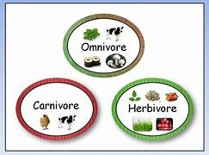

Session 7: Science—Carnivores, Herbivores and Omnivores.

L.O: I am learning to identify and name carnivores, herbivores and omnivores.

Children will look at their favourite animals and explore whether they are carnivores, herbivores and omnivores. They will then put the pictures into the venn diagram.

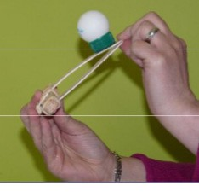

Session 10: D&T

L.O: I am learning to generate, develop, model and communicate their ideas through talking, drawing, tem-

plates, mock-ups and, where appropri- ate, information and communication technology.

Children will be designing their catapult by drawing it and writing what they will need to make it.

1- Castles and Fairy tales

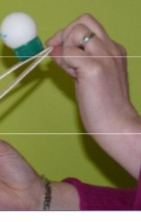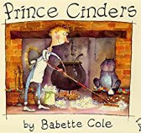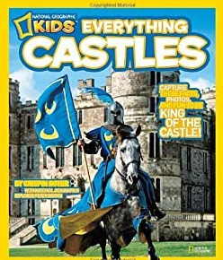

eek 4:

Session 12: D&T

ols and equipment to

L.O: I am learning to evaluate my work.

de-

Week 6:

Week 5:

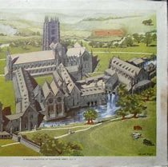

of a location.



Session 3: Science—Animal groups

LO: I am learning to identify and name a variety of common animals including fish, amphibians, reptiles, birds and mammals.

Children will looking at mammals, insects and birds. They will sort small world animals and pictures into each group.

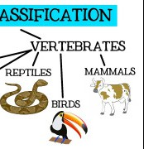

cture of a variety of nd mammals including

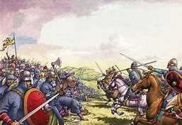

Session 6: History

LO: I am learning to recognise significant historical places in locality.

Children will be introduced to the battle of Hastings, that William Duke of Normandy won and became known as William the Conqueror. Children to label a picture of a motte and bailey castle and investigate what the different rooms in a Castle is for.

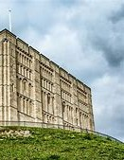

laces in locality.

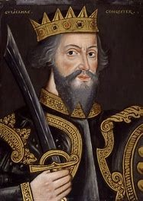

Session 9: History— Battle of Hastings

L.O: I am learning about events beyond my living memory.

Children will be finding out who William the Conqueror is and what happened in the Battle of Hastings. Children will use role play to act out some of the battle using freeze framing. The children will then draw a picture of the Battle of Hastings and write key information that they have learnt so far.

Session 14: ART

L.O: I am learning to explore an artists work.

The children are going to be learning about Paul Klee’s artwork and his life. They will explore and compare different pieces of his work. Children are going to have a go at making a collage in the style of Paul Klee’s work.

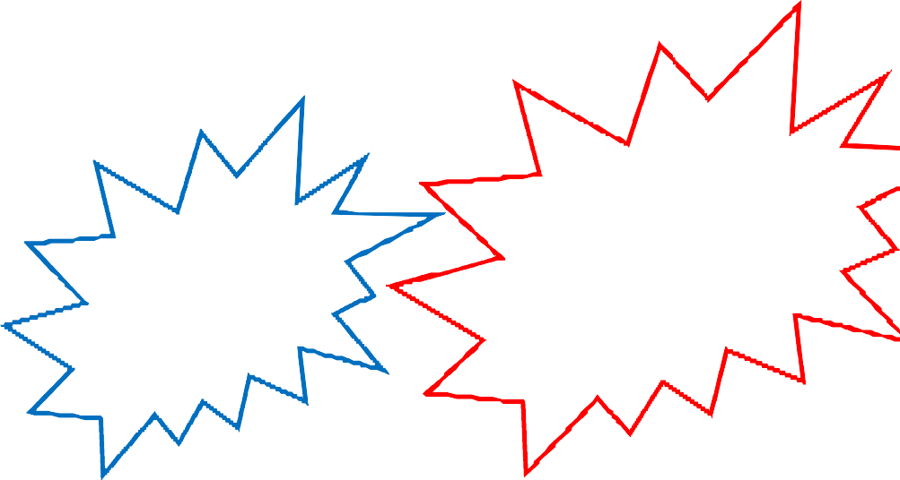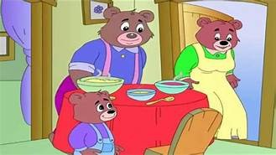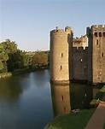

Session 19: French

Session 20: History

L.O: I am learning to use vocabulary related to size.

L.O: I am learning about events beyond my living memor

The children will be looking at the three different sizes of the bears and will

start to learn the vocabulary relating to size. The children will hunt for items around the classroom and use the vocabulary that they have learnt to compare the sizes.

The children will be learning going to think about what life

like in Norman times. As a class, we are going to start to write a diary of what it would be like as a Norman child living in a Castle.

P.E:

Fundamental skills- KS1

R.E:

We will be looking at repentance through Judaism.

Cambridge Scheme of

Work

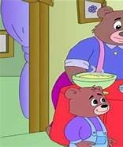

Session 17: French

L.O: I am learning to become familiar with the main chara

book, greetings and introductions.

This will be an introduction to Goldi- locks and 3 bears. Children will be using the puppets to act to introduce themselves in French.

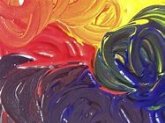

Session 13: ART

L.O: I am learning how to mix primary colours.

The children will use different colours paints to explore what happens when they mix two different colours together and what colour is made.

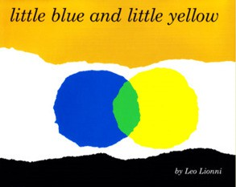

Session 16: Philosophy for Children– Colour

We will read the story ‘Little Blue and Little Yellow’ by Leo Lionni. We will be exploring how colour influences our lives. The children will colour in two similar shapes in different colours. They

will then reflect on the different pictures.

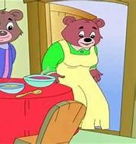

cters in a story

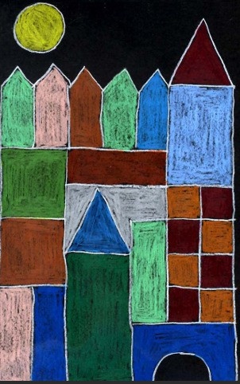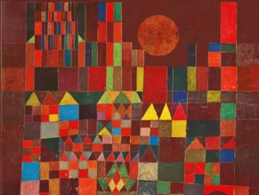

Session 15: ART

L.O: I am learning to develop a wide range of art and design techniques in using colour, pattern, texture, line, shape, form and space.

The children will be creating a piece of artwork in the style of Paul Klee. They will need to draw their castle and then paint block colours being inspired by Paul Klee’s work.



Session 18: French

L.O: I am learning to practise numbers 0-10 in French.

The children will be learning their numbers in French and practising counting.

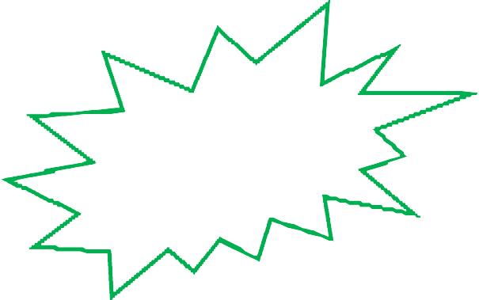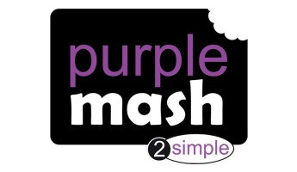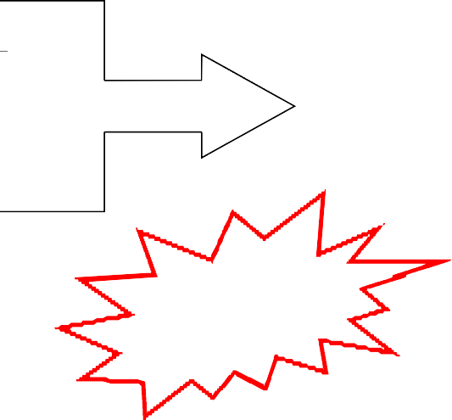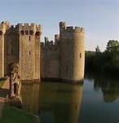

y.

would have been

PSHE:

We will be leaning about myself

and my relationships (4) beginning and belonging.

SMSC:

Social Day

Music:

Computing:

Year 2: Hands, feet and heart.

Purple Mash 2.3

Spreadsheets